1949 Beech A35 Bonanza
N8558A
Serial #: D-1980

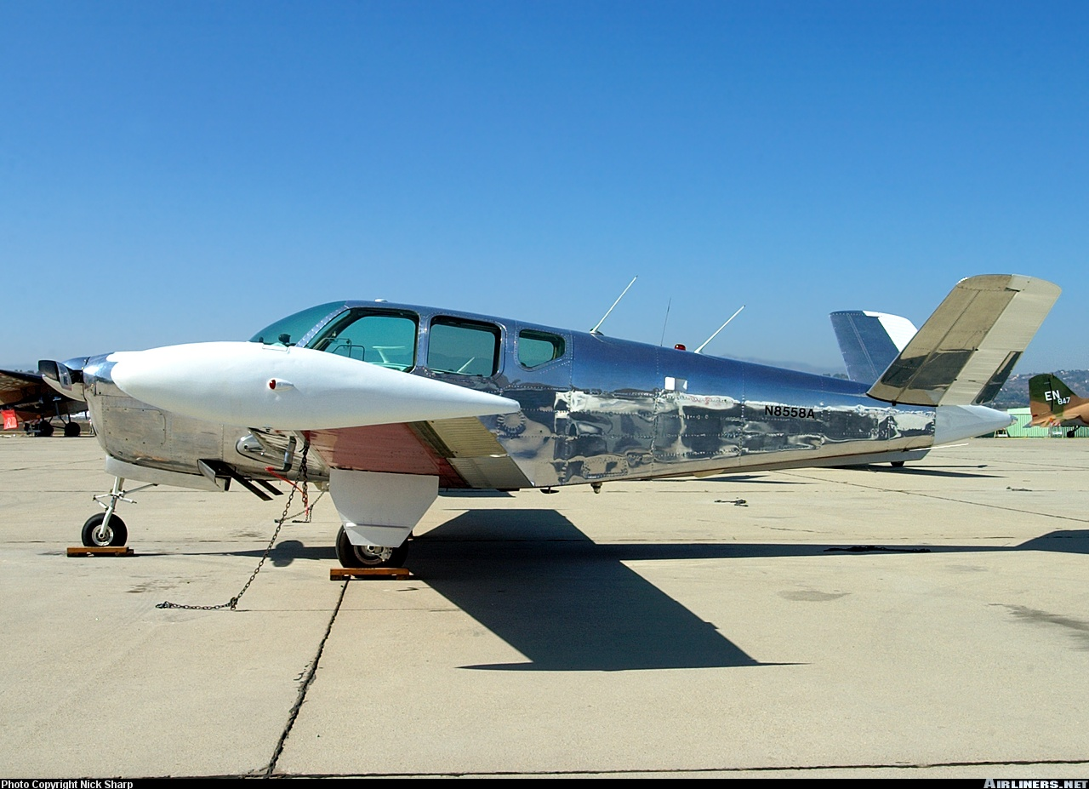

1) 4/27/1949 Tradewind Airport Corporation (Amarillo, TX) Dealer, Shelby Kritser

2) 4/27/1949 Panoma Corporation, (oil & gas) Andre Fabris Lopez, sold company in 1954 for $118,000,000.00 (Amarillo, TX)

3) 2/9/1954 Amarillo Flying Service (Amarillo, TX) $7,381.50

4) 10/23/1954 Harley Davidson Motorcycle, Inc. (Amarillo, TX) Eldon Jay Beers, President (motorcycle racer)

5) 9/24/1959 Tradewind Airport Corporation (Amarillo, TX)
Dealer

6) 1/15/1960 James L. Johnson, M.D. & K.N. Whipple (Amarillo, TX) $7,200.00

7) 6/3/1963 Edward F. Thomas, & K.N. Whipple, & James S. Kone (Amarillo, TX)

8) 6/7/1967 Tradewind Airport Corporation (Amarillo, TX) Dealer

9) 11/13/1967 Wel-Tex Corporation, Clifton E. Hartman & James Edward Nix, Partners (Wellington, TX)

10) 7/11/1969 Wes-Tex Corporation, same partners (Wellington, TX)

11) 7/14/1969 Aircraftsman, Inc., Otto O. Hess Jr. (Bethany, OK) $7,780.50

12) 9/25/1970 Tulakes Aviation, Corporation (Bethany, OK)

13) 7/13/1971 James D. Hale (Pawnee, OK)

14) 7/13/1971 Edward B. Baker (Perry, OK)

15) 7/29/1976 S & T, Co. Ralph J. Sommicksen (Dalhart, TX)

16) 12/8/1978 Glen & Helen Aircraft, Inc. dba G & H Aircraft (El Monte, CA) $12,500.00 Glen Nickerman

17) 1/31/1979 Leon F. Haskins & Sheila Anne Haskins (Newbury Park, CA)

18) 7/7/2025 AIRCAPITAL NEVADA, INC. (Carson City, NV)

