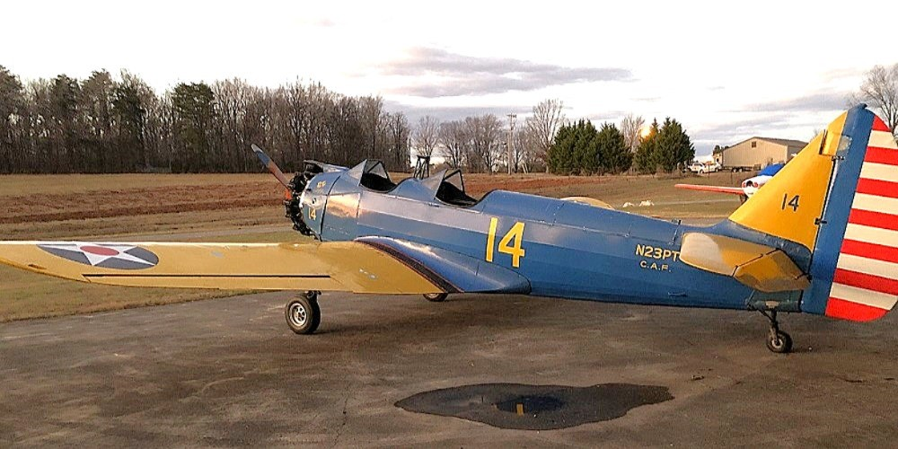
Our wonderful old 1942 Fairchild PT-23 (M-62C) manufactured by the St Louis Street Car Company for Fairchild during WWII was in great shape when we had to park it around 20+ years ago. She has always been hangared and is still in pretty good shape for her age, but does need some attention. The engine was run and the airplane was taxied until around 10 years ago. Since then, the engine was pulled thru and compression was good on all cylinders.
Total time on airframe is 858.5 hours. She had 175.05 hours when purchased by original owner at Cape Girardeau, MO (Harris Field War Assets Administration) on 26 Apr 1946. AAF tail number was 42-49887. Current time on engine (SN 15660) is 441.6 SMOH.
Sale includes the following: all logs & records since purchased from WAA; extra W-670 engine (SN 26288) with 630 hrs SMOH.; extra very low time Sensenich wooden prop and hub assembly; NOS expander tube brake kit; a couple of W-670 parts engines that were out in the weather a long time might come in handy; two speed 115v inertia starter motor; surplus NOS BG spark plugs; AAF W670 tool kit; a few various instruments; several manuals (Complete AAF Fairchild PT Dash 1, 2, & 3, Continental R-670 & W670 Operating, Parts, & Overhaul manuals), and more.
The plywood on upper wings were covered with fabric in 1947 and the fabric needs to be replaced. The mahogany appears good. One prop needs overhaul and the other was stripped of varnish for long term storage years ago and needs refinished. Disassembled and cradled, palleted, or jigged for easy shipment. Email us for more info & photos,
She's a rare jewel and an absolute delight to fly! $69,500 takes everything
Email 1942PT23@gmail.com or call Lou at 865 771-0638 (mobile). Please leave text message if no answer.

Included with the sale:
1. Spare engine W670-6N SN 26288 with what appears from the engine log
book to be 630 hours since major overhaul
2. Spare very low time Sensenich prop model 90LA78, serial number M1271 in
bare wood for long-term storage.
3. Spare complete low time prop hub for above.
4. NOS expander tube brake kit that includes two expander tubes, 18 brake
pucks, and a box with 18 clips. (for Goodrich/Hayes brakes on Fairchild PTs).
5. Two junk Continental W670 engines with junk parts than may someday be
helpful.
6. JAHCO two speed 115v electric inertia starter crank
7. Inertia starter manual crank
8. Battery box from a PT-26
9. Several dozen surplus new old stock (NOS) BG spark plugs for Continental
R/W670s.
10. NOS inserts (“cigarettes”) for 670 ignition harness
11. Many 670 NOS gaskets and what I believe to be engine mount bushings for 670s
12. Continental R/W670 piston rings.
13. Surplus AAF R670 tool kit appears complete, but may not be.
14. Spare NOS Firestone Sky Champion 10.00 SC static conductor tailwheel tire.
15. Complete AAF Manual set that came with the PT-23 when purchased from WAA.
16. Three Continental R670 & W670 manuals. Two are WWII era: Operating and
Maintenance Instructions and Overhaul Instructions. The third is copyright
1958: Overhaul Manual and Parts Catalog.
17. Cradle of Heroes by H.L. Puckett (detailed history of Fairchild PTs
18. Several old instruments in unknown condition: 2 tachs; 2 whiskey compasses;
1 clock; 1 turn & slip; 2 oil temp, oil press, fuel press combo gauges, one with
capillary. (one of the compasses appears British)

