RV-14 Slow Build Project.

Empennage/cone, wings and fuselage kits complete. Well into the finishing kit.

Included in the project:

- Engine: Lycoming YIO-390-EXP119 Dual Pmags – New, in crate
- Hartzell PROP C2YR-1BFP/F74972 – New, in box
- Firewall Forward kit including prop governor, exhaust, alternator, etc
- Avionics:
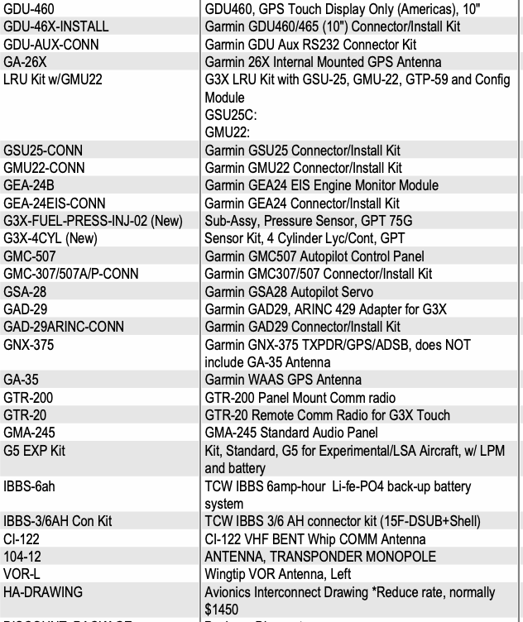

- VP-X-PRO
- Interior from South Florida Sport Aviation
  - Seats
  - Carpet
  - Glare Shield Cover
- FlyLED Landing/Taxi/Position/Strobe lights (wingtip and leading edge) – installed
- Crow Seatbelts
- Aircraft Specialty Instrument panel partial payment and example cut blank ($1,000 due for final version)
- Cascade Customs and Design paint 25% deposit $3,870.94 (transferable)
- Evoke Design 50% deposit $800 (transferable)

Located in Locust Grove, GA

