1957 Cessna 182 Jump Plane
For Sale – $85,000 OBO
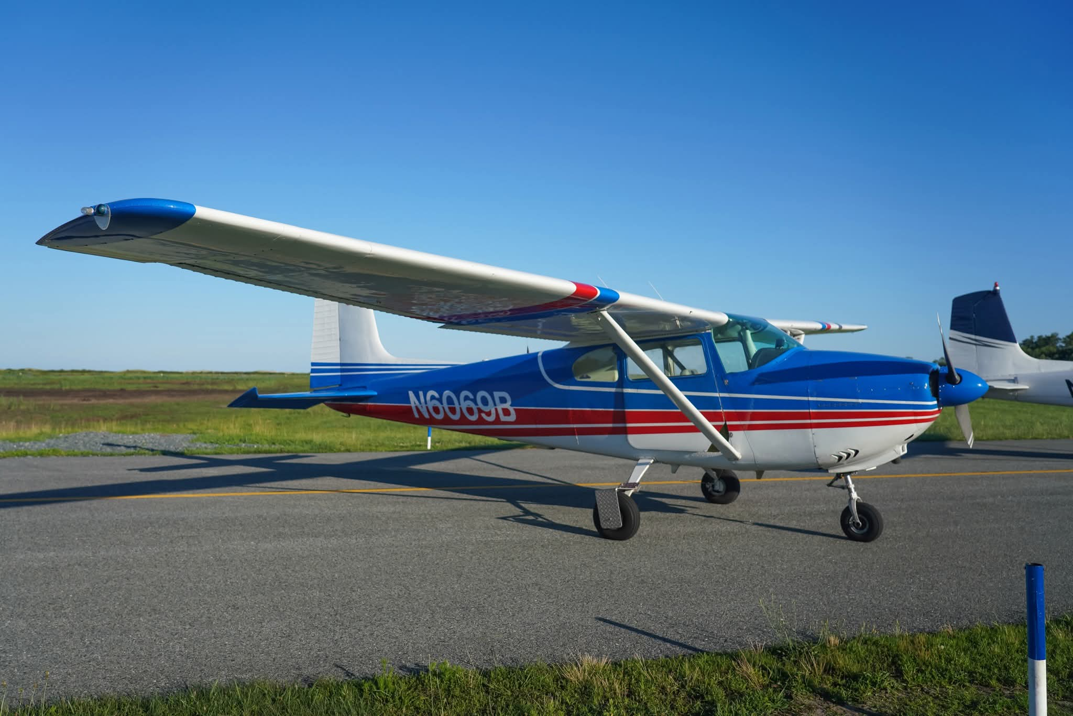

Specifications
Engine | Continental O-470
Current Tach | 1306.5
Total Time Airframe (TTAF) | 5,151
SMOH | 997.4
Cylinders | Four cylinders recently replaced. Remaining cylinders have approximately 50 and 100 hours.
Last Annual | August 29, 2025
100-Hour Inspection Due | Tach 1367.1
STOL Kit | Wing-X STOL Extensions
Useful Load | 1,352 lbs
ADS-B | ADS-B Out Compliant (TailBeacon)
Interior | 5/10

Owner Comments
This aircraft has been exceptionally well cared for and maintained under Part 91 operations. Every pilot who has flown her has enjoyed flying this airplane. She has always been hangared and offers the flexibility to remain a jump aircraft or be converted back to a personal or recreational aircraft, depending on your needs. With the recently installed cylinders, one of the major engine maintenance items has already been addressed, giving the next owner added peace of mind and helping reduce near-term maintenance costs.

Highlights
- Excellent jump plane with the flexibility to convert back to a personal aircraft.
- Always hangared.
- Wing-X STOL extensions for outstanding short-field performance.
- ADS-B Out compliant.
- Ready for work or weekend flying.

