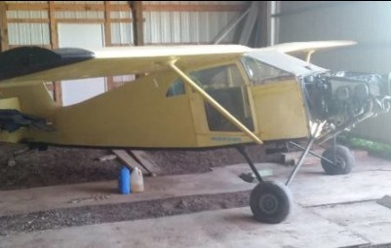
Barn find Cougar / Tailwind

I bought this thinking it would be a quick recover and fix job. There’s more to do than I have time for. This is a restoration project. The fuselage needs repair in spots around the doors primarily. I purchased the plans for the “Clement Mods” for a Tailwind which effectively replace all of those tubes and I intended to use those plans to make the doors bigger and move the seats back for taller people. Once the fuselage repairs are done it’s a reassemble and recover effort.
The engine was reportedly running but I never tried to start it. It has 170.2 hours based on the log books and chrome cylinders. The cylinders have been coated with oil for storage. It’s an O290D which was converted from a G.
All parts from the original plane are included. The instruments are untested but they’re all there and still in the original panel. The fuel tank has a leak and will likely need to be replaced. I believe the gear are bent beyond repair and will need to be replaced with gear from a Tailwind or an RV6A (not an RV6). New replacement RV6A gear can be purchased from Langair.
Things like brakes, pedals, pulleys, knobs, etc. are all there and you just need to decide whether to restore or replace them.
All of the fabric patterns have been saved so you know how much to order and how to cut the new fabric. Also, the interior seat frames, doors, etc are all included, but the original fabric was soaked in mouse urine so I had to get rid of it.
The original cowl and a nice IVO prop are also included. The cowl is heavy and has been repaired in the past. It would likely need additional repairs or replacement.

