* MOSAIC * MOSAIC * MOSAIC * MOSAIC *
RV-6A Slider. N216A
Dubuque, IA (KDBQ- hangered)
$102,300

Reliable, upgraded, affordable RV 6A plane to jump in and fly, build hours and enjoy!
Purchased 2 years ago to build time while building a 14A. It is fast, fun and responsive. At purchase, we upgraded to IFR, added Sure Fly mag, Garmin autopilot, dual G5s and Garmin nav-com. We have flown it over 100 hours since purchase to Florida, Georgia, Colorado, Nebraska and locally in the upper Midwest. Always hangered. No damage history. Logs available.

ENGINE
Lycoming HIO-360B1A. 180HP. Approx. time SMOH 1335 hrs
Fuel Injected- fuel injector servo overhauled 10/2024
Sure Fly Mag (installed 8/2023) and Slick Mag (7/2021). Have the other overhauled Slick Mag if you want it
Sensenich Ground adjustable composite prop (installed 12/2022) Approx time since new 100hrs
Starter (new 7/2021)
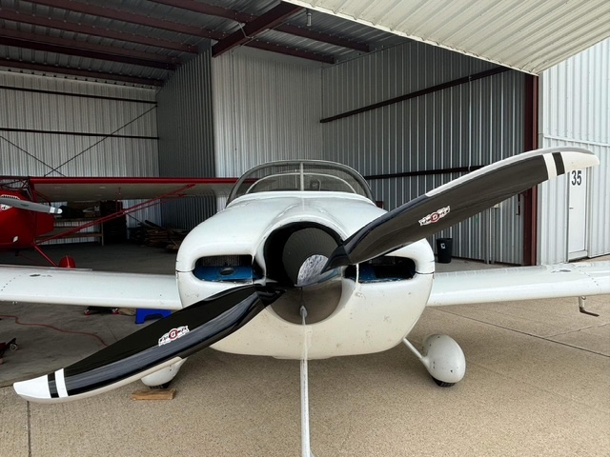
Fuel sending unit and pressure gauge (new 8/2023)
Alternate air source for fuel injection added (7/2023)
Battery (new 8/2023)
Battery tender
Tanis heater (new 7/2023)
Vetterman Heat muff (new 9/2023)
Extended oil neck (7/2023)

AVIONICS
Garmin Dual G5 Flight Instruments (new 7/2023)
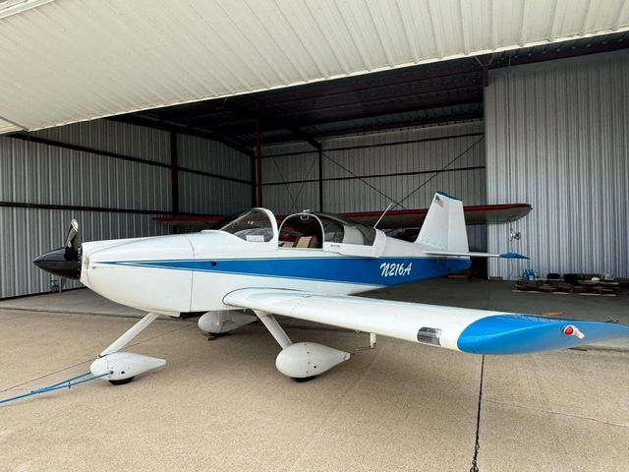
Garmin Nav0com GNC355 (new 7/2023)
Garmin Autopilot GFC500 (new 7/2023)
Garmin GTX327 transponder (overhauled 8/2023)
Engine Monitor JPI EDM 350 IAW (new 12/2022)
ADSB in/ out EchoUAT (new 7/2023)
Heated pitot tube

AIRFRAME – TTAF 515 hrs approx. (100+ in last 24 months)
Electric Flaps
Electric Trim
Stick Grips with PTT, electric trim and AP disconnect R & L seat
R& L fuel tanks removed and re-sealed for minor leaks thru rivets (some bluing on white paint remains)
New main tires and tubes (4/2025)
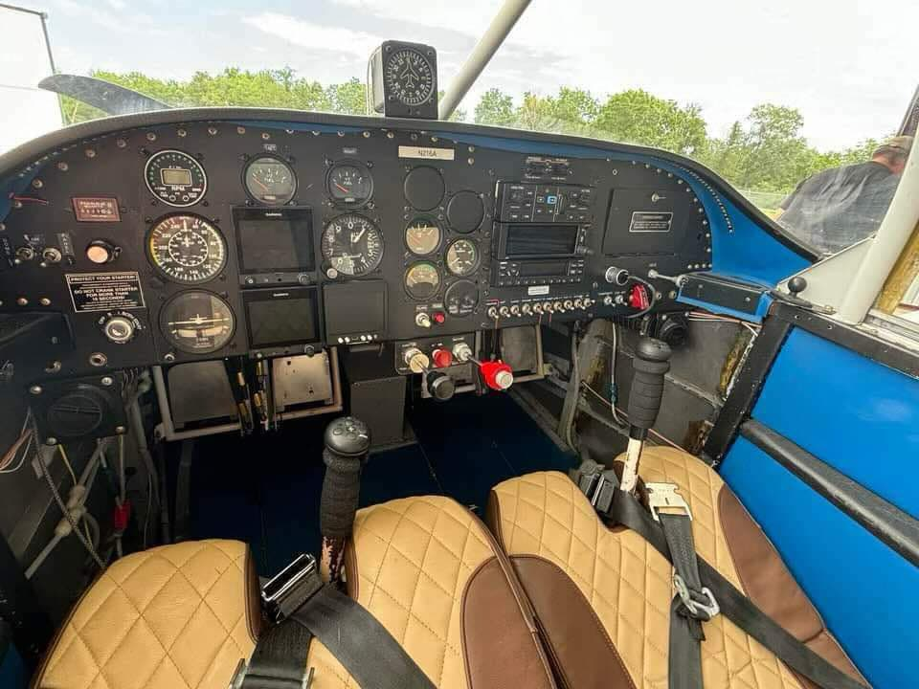
Kroger sun shade
Canopy cover
Control lock
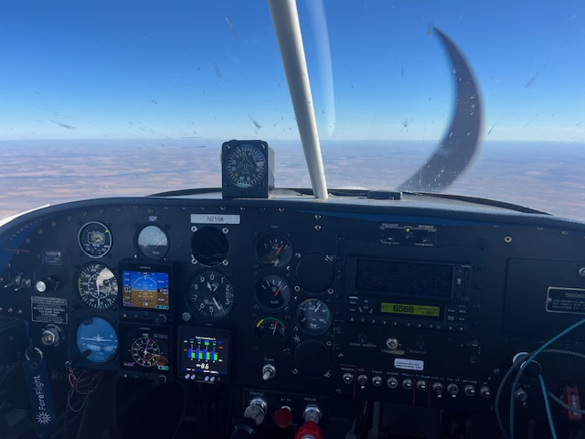
Dual USB charger port
Paint – 6-7/10
Interior – 5-6/10

CONDITION INSPECTION 10/2024
Compressions 79, 79, 79, 78
Minor pitting (unchanged from 6/23 condition inspection and photos)
#4 exhaust gasket replaced
All slip joint bolts replaced
Oil filter – no metal; sample sent – clean

Call/ contact for more information:
Erin Kennedy. 563-599-6300

