AIRCRAFT INFO SHEET
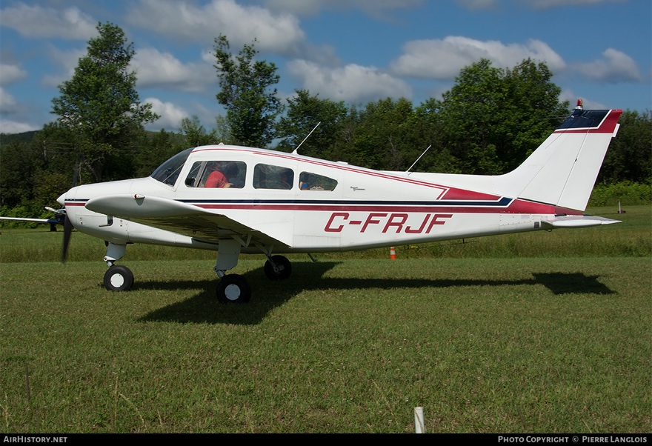
Make: Beechcraft
Model: Musketeer A23
Year: 1964
Registration: C-FRJF
Serial Number: M-565
Engine: Continental IO-346-A (#10010-3-A)
Prop: Sensenich M74DC-0

- Empty Weight: 1441.8 Lbs
- Useful Load: 958.2 Lbs
- TTAF= 3415.7
- Engine SMOH: 567.6
- Next Annual: 01 November 2025

