OWNER'S OPERATING GUIDE
FOR THE
PIPER J-4A-85 CUB COUPE
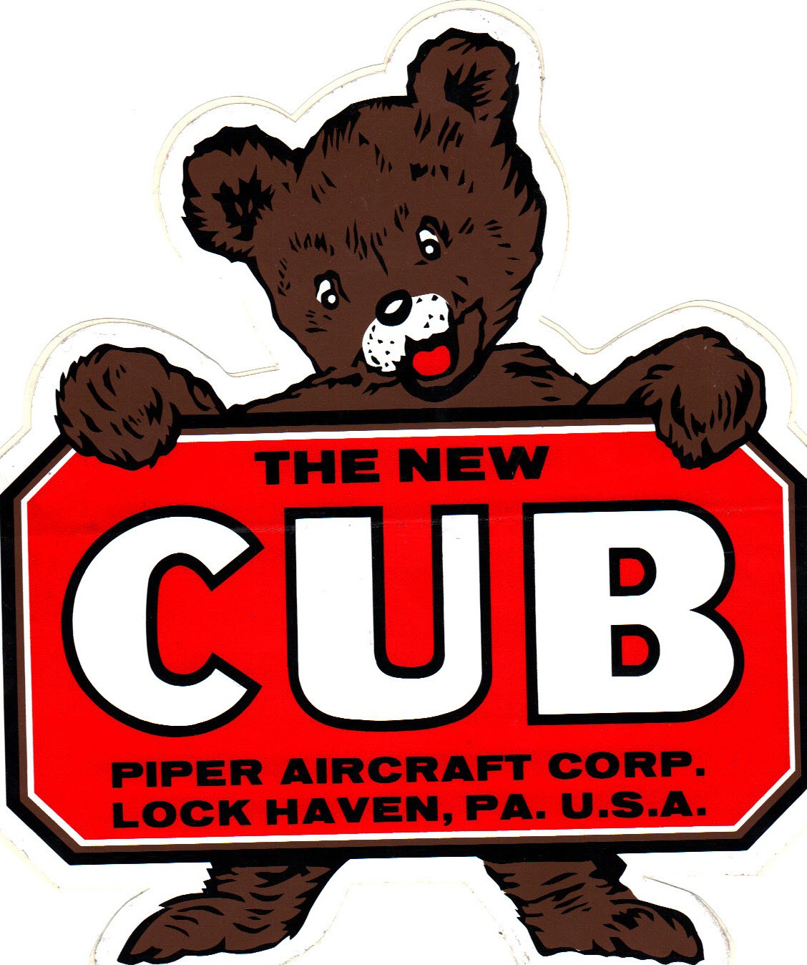
Piper Aircraft Corporation did not provide an owner’s manual for their early Cub aircraft. Various early operators developed owner’s handbooks and operating manuals for the more plentiful J-3 Cubs. This unofficial guide was created from various sources and was edited to reflect information specific to the J-4. (A 65-horsepower J-3 Owner’s Manual is attached to this document as further reference.)

WARNING: The pilot is responsible for ensuring the accuracy of the information contained in this document and its applicability for the specific aircraft being flown.

The following is an excerpt from the original FAA J-4 Aircraft Specification containing information specific to the J-4A aircraft:

DEPARTMENT OF TRANSPORTATION
FEDERAL AVIATION ADMINISTRATION

AIRCRAFT SPECIFICATION NO. A-703 (Abbreviated)

Type Certificate Holder Piper Aircraft, Inc. 2926 Piper Drive
Vero Beach, Florida 32960

Type Certificate Holder Record The New Piper Aircraft, Inc transferred TC A-703 to Piper Aircraft, Inc on August 7,
2006.

Engine Continental C-85-12 (Engine limits for all operations, 2575 r.p.m.) (85 h.p.)

Propeller: McCauley Model 1A90 (Diameter: Not over 74 in., not under 72.5 in.)
Static r.p.m. at maximum permissible throttle setting: Not over 2250, not under 2060. No additional tolerance permitted.

Fuel 73 min. octane aviation gasoline

Engine Limits For all operations, 2575 r.p.m.

Airspeed Limits Level flight or climb 100 mph True Ind.
Glide or dive 135 mph True Ind.

C. G. Range (+12.9) to (+21.0)

Empty Weight C. G. Range (+14.9) to (+17.1) when auxiliary fuel tank is installed.

Maximum Weight 1,301 lbs.

Number of Seats 2 (+19.5)

Maximum Baggage 105 lbs. (+43.5)

Fuel Capacity Main Tank: 16 gallons (-10.5)
Auxiliary Tank: 9 gallons (+54.0)
Placard fuel selector valve: “Use main tank for takeoff and landing. In level flight, use
auxiliary tank before using main.”

Oil Capacity 5 quarts (-30)

Landing Gear 8.00-4 wheels with brakes (Goodrich 841) and tires
Leaf spring tail wheel installation, Dwg. D395-E or D3010-E

[END]

Specifications for J-4A (C-85), N35001
Empty Weight 842 lbs.
Useful Load 460 lbs.
Baggage Capacity 105 lbs.
Maximum Gross Weight 1,301 lbs.
Takeoff Roll (@Max Gross Wt.) 370 ft.
Landing Rol (@Max Gross Wt.) 290 ft.
Fuel Capacity (25 gal total) 16 gal Main Tank
9 gal Aux Tank
Fuel Burn 4.5 gal./hr.
Cruise Range 2.6 hrs.
Best Rate of Climb (Vy) 450 ft./min
Absolute Ceiling 14,000 ft.
Cruise Speed 73 mph
Top Speed 83 mph
Stall Speed (Vs) 39 mph
Best Glide 50 mph
Approach Speed 45-55 mph
Green Arc 39 – 90 mph
Yellow Arc 90 – 122 mph
Red Line (Vne) 122 mph

GENERAL OPERATING PROCEDURES

The Piper J-4A Cub Coupe represents years of diligent aircraft engineering and manufacturing experience. Its simplicity of design and construction, its low operating and maintenance costs, inherent stability, ruggedness, outstanding safety, ease of flying, and side-by-side seating make it a great airplane to learn in and fly.

  - PREFLIGHT INSPECTION: Each pilot should become familiar with his aircraft so that he can accomplish a satisfactory pre-flight inspection. The check is simple and requires only a few minutes. The daily check of the airplane prior to flight should be the first in a number of safe flying habits the pilot should acquire.

Preflight Inspection—Cockpit
- Magneto Switch—Verify the mag switch is in the OFF position
- Throttle—Closed (full aft position)
- Fuel selector—Set the fuel selector on to the MAIN TANK position
- Trim—Use the hand crank to move the red trim indicator to the center position and verify the trim tab on the elevator is aligned with the elevator
- Primer—Verify the primary is pushed in and locked
- Carb Heat—Verify the carburetor heat knob is pushed in to the OFF position
CAUTION: The center of the knob must be pushed in before moving the carb heat knob to avoid damaging the mechanism.
- Rudder pedals and brake linkage—Check to ensure cables and linkages are fastened and secured
- Brake Reservoirs—Check for signs of fluid leakage
- Control Stick Cable Attachment—Check to ensure cables and linkages are fastened and secured
- Baggage Compartment—Ensure all loose items are stowed and the baggage compartment is closed.
- Check the fuel quantity indicated on the auxiliary tank fuel gauge located on the right side of the back cabin wall

Preflight Inspection—Nose
- Windshield—Clean and inspect for cracks
- Engine Oil—Check the oil level in the engine sump by removing the oil cap and dipstick gauge. The dipstick indicates the oil level up to the top index mark of 5 quarts. If the oil level is at or below 3 quarts, add additional oil before starting the engine. Reinstall and secure dipstick.
- Check engine and the ground underneath for evidence of fuel or oil leaks
- Cowling Pins—Verify the pins are in and properly seated and secured
- Exhaust System—Verify exhaust pipes are secure
- Main fuel tank—Visually check fuel quantity and ensure cap is on and secure
- Fuel float gauge—Check quantity and that the ball floats freely. The gauge shows the proportion of fuel in the tank by the floating ball in the tube on the center of the upper engine cowl. A full tank of 16 U.S. gallons will be indicated by the ball floating at the top of the tube. Keep the fuel gauge clean.
- Propeller—Check condition for nicks and other damage
- Drain a fuel sample from the gascolator under the main tank and inspect fuel for water and solid contaminants

Preflight Inspection—Right Landing Gear
- Check wheel nuts and cotter pins are secure
- Check for brake leaks
- Inspect the tire condition (no cord showing) and for proper inflation

Preflight Inspection—Right Wing
- Inspect wing strut attachment bolts and ensure they are secure
- Inspect the wing surface condition for any damage
- Confirm the aileron is free and the attachment bolts are secure
- Check that the aileron cable is secure, clean, and not binding
- Auxiliary fuel tank—Ensure the fuel cap is on and secure.
- Remove the inspection hole cover under the fuel tank on the bottom of the fuselage. Drain a fuel sample from the gascolator under the auxiliary tank and inspect fuel for water and solid contaminants. Reinstall the inspection plate.

Preflight Inspection—Fuselage Right Side
- No fabric damage
- Check belly for damage and leaks

Preflight Inspection—Tail Section
- Confirm the horizontal stabilizer and trim tab are secure and free of any damage
- Check condition and tension of lying wires and connecting bolts
- Check the security and condition of the vertical stabilizer .
- Check the security and condition of the elevator and rudder hinges
- Confirm that the rudder and Elevator moves freely

Preflight Inspection—Tailwheel
- Confirm the springs and chains are in place and secure
- Check the bolts securing the leaf spring
- Check the tailwheel for proper condition and wear
- Check the bushings at the steering spring attachment points for wear

Preflight Inspection—Fuselage Left Sid
- No fabric damage
- Check belly for damage and leaks

Preflight Inspection—Left Wing
- Inspect wing strut attachment bolts and ensure they are secure
- Inspect the wing surface condition for any damage
- Confirm the aileron is free and the attachment bolts are secure
- Check that the aileron cable is secure, clean, and not binding
- Check pitot tube for condition and obstructions

Preflight Inspection—Left Landing Gear
- Check wheel nuts and cotter pins are secure
- Check for brake leaks
- Inspect tire for condition (no cord showing) and proper inflation

  - STARTING THE ENGINE
- Ensure the pilot and passenger side (if occupied) seatbelts are securely fastened.
- Check the brake pressure by applying pressure with your heals. Apply and hold the brakes to ensure the aircraft does not move during engine start.
- Verify the magneto switch is in the OFF position.
- Push the mixture control in to the full rich position.
- Turn the fuel selector switch to the Main Tank position.
- Pull the primer out, pump three or four times, then reseat primer and lock by turning it in the opposite direction. In extremely cold weather a few strokes of the primer as the engine starts will enable it to keep running. NOTE: Avoid excessive priming as it causes raw gasoline to wash lubricating oil from engine cylinder walls. Do not prime a warm engine.
- Set the throttle approximately 1/10 open.
- Turn master electrical power switch ON.
- Ensure the surrounding area is clear of people and loose items. Give a loud verbal “Clear” warning.
- Start the engine by pulling starter switch out—push the switch in as soon as the engine starts.
- If engine does not start, prime the engine a second time with two additional strokes of the primer.
- Repeat starting procedures in step 10.
- If the engine loads up and refuses to start, turn ignition switch "OFF," open the throttle fully and turn the propeller through backwards several times to unload excessive gas mixture in the cylinders. Then close throttle and repeat starting procedure.
CAUTION: Always handle the propeller as if the mag switch is "ON" and the engine is ready to fire.

  - ENGINE WARM-UP
- As soon as the engine starts, advance the throttle slightly to idle at 700 rpm. Check the engine instruments. If the oil pressure gauge does not indicate pressure within 30 seconds, stop the engine immediately, check and correct the trouble before any further operation. Oil temperature during operation should not rise above 220° F. and oil pressure should not fall below 30 pounds. With the engine warm, idling speed should be 550-600 rpm.
- Rev the engine up to 2100 rpm. Switch to ·LEFT and RIGHT magnetos and watch for an rpm drop of not over 75 rpm. CAUTION: Do not operate the engine on either single magneto for more than 30 seconds at a time, as this tends to foul the non­operating spark plugs in the ignition circuit of the magneto that is switched off.
- Turn intercom system and portable radio on (if installed,) set the appropriate frequency and adjust the volume as appropriate.

  - TAXIING
- Open the throttle to start the airplane in motion and check brakes to ensure proper operation.
- Taxi with the minimum power necessary to keep the airplane rolling. Do not keep the rpm higher than necessary to control the taxi speed of the airplane with minimal use of the brakes. This causes unnecessary wear and tear on brakes and tires.
- Taxi slowly (speed of a fast walk) controlling direction with rudder which is connected to a steerable tail wheel. Use brakes only for positive, precision ground control when necessary.
- Taxi upwind with the stick back; downwind with the stick forward. When ground winds are in excess of 15 mph, turn into the wind using ailerons in the direction of the turn; apply ailerons away from the turn when turning downwind. This procedure helps to prevent the wind from "picking up" a wing during windy, gusty conditions.
- Check proper operation of the magnetic compass and the ball during a turn.
- Always make ground turns slowly.

  - BEFORE TAKEOFF
- Check proper deflection of all flight controls by activating the aileron, elevator, and rudder in all directions.
- Confirm the fuel selector is in the Main Tank position and adequate fuel quantity is showing in the fuel gauge.
- Check and set the elevator trim in the neutral position by moving the overhead trim handle to place the red indicator ball in the centered position.
- Confirm proper operation of the engine and ignition system by increasing power to 1,700 rpm. Move the magneto switch to the Right position and watch for an rpm drop not to exceed 175 rpm. Move the magneto switch back to the Both position and rpm should return to 1.700 rpm. Repeat the mag check by selecting the Left mag and watch for a similar drop in rpm. The difference in the rpm drop between the two mags should not exceed 50 rpm. Return the mag switch to the Both position.
- With the engine still at 1,700 rpm, push the button in the center of the carburetor heat knob and pull the knob out to activate the carburetor heat. Confirm proper operation of the carburetor heat by noting a slight rpm drop with the carburetor heat on. Turn off the carburetor heat and reduce the throttle to idle rpm. NOTE: The carburetor heat should always be fully off or fully on. Do not use partial carburetor heat.

  - TAKEOFF
- Smoothly advance the throttle to full power for takeoff and make a quick check of oil temperature and pressure after applying full power to ensure proper operation. Takeoffs can be safely performed by performing a wheel takeoff or lifting off from a three-point attitude.
- To make a wheel takeoff, begin the takeoff ground roll with the stick full forward and the aileron deflected as necessary to compensate for any crosswind. Neutralize the elevator as the tail begins to rise to maintain a level attitude during acceleration. Gently apply up elevator as the airspeed passes 40 mph to smoothly lift off the ground. Allow the aircraft to accelerate to 55 mph and continue the climb.
- To perform a three-point takeoff, begin the takeoff ground roll with the stick in the neutral position (with aileron deflected as necessary for crosswind.) The aircraft will become airborne at approximately 39 mph. Allow the aircraft to accelerate to 55 mph and continue the climb.
- To perform a short-field takeoff, hold the brakes with the stick full aft and smoothly apply full power. Check the engine instruments for proper indications and release the brakes. As the tail begins to rise, hold the tailwheel about 6 inches above the runway surface. As the aircraft lifts off the ground, establish a climb speed of 50 mph. Once the aircraft has cleared a 50’ obstacle, increase speed to 55 mph for the remainder of the climb.
- Adjust the elevator trim as necessary during the climb to relieve control stick pressure.

  - CLIMB
- Climb at an airspeed of 55 to 60 mph
- Do not fly at full throttle over 3 minutes

  - CRUISE
- Set cruise power to 2,100 rpm.
- Adjust the trim as needed to maintain level flight without applying elevator stick pressure
- If there is fuel in the auxiliary tank, switch the fuel selector switch to use fuel from the auxiliary tank
- Use carburetor heat when engine runs "rough" and tachometer shows a drop in rpm which may be due to ice forming in the carburetor. The tachometer should recover to within 50 rpm below normal when using carburetor heat. Push the carburetor heat to "OFF'', and if icing condition has been cleared, rpm should return to normal. Continued use of carburetor heat will only cause increased fuel consumption and loss of power.

  - DESCENT
- Switch the fuel selector to the Main Tank position.
- Apply carburetor heat when using power settings less than 2,000 rpm.
- The maximum permissible diving speed is 122 mph
- Clear the engine by opening throttle gently, every 200-250 feet of descent during a long glide so that engine temperature will be maintained.

  - APPROACH AND LANDING
- Pull carburetor heat ON prior to throttling back for glide or for any other flight maneuver.
- Glide between 50-60 mph depending upon loading of the airplane and gust conditions.
- Throttle action on the part of the pilot should be smooth and gentle at all times
- Approaching ground level, reduce power smoothly and gradually increase back pressure with the control stick to allow the airspeed to decrease toward stall speed. The aircraft should touch down smoothly on all three wheels simultaneously as the aircraft nears stall speed.
- At touchdown, move the control stick smoothly to the full aft position.
CAUTION: Abrupt aft movement of the control stick above stall speed can jerk the aircraft back into the air below safe flying speed. If that happens, immediately apply full power and execute a go-around.
- In the event of strong crosswinds or gusts, the pilot may elect to make a wheel landing by maintaining an airspeed of 50-60 mph and allowing the main wheels to roll smoothly onto the ground. After main wheels touch down, apply elevator inputs as necessary to keep the tail up as the aircraft slows down. After the tail touches the ground, apply full back pressure on the control stick.

  - GO AROUND
- If the approach path is unstable or excessively high or low, or in the event of a bounce or directional control problem on landing, an immediate go around should be executed.
- Smoothly but aggressively apply full throttle and establish a climb airspeed of 55-60 mph.
- With the aircraft under control, turn off carburetor heat and adjust trim as necessary.

  - ENGINE SHUTDOWN
- Never cut the engine immediately after landing as this causes the engine to cool too rapidly. Idle the engine, especially in high temperature operating conditions, for several minutes. It is advisable to switch to each magneto for 30 second intervals to allow gradual cooling of engine. This helps to prevent overheating of spark plug insulators and will lessen tendency for "after-firing."
- Check to confirm the carburetor heat is off during idling.
- Pull mixture out to full lean position. NOTE: The engine will continue to run with the mixture in the full lean position.
- Shut down engine by turning the magneto switch to OFF.
- Turn the electrical master switch OFF.
- Move the fuel selector switch to the OFF position.
- Turn the portable radio and intercom switches off.
- Enter the flying time in the aircraft time books.
- Chock the wheels to prevent the aircraft from rolling.
- If the aircraft is not to be flown for some time, it should be hangared or tied down. Use good quality ½ to 5/8" diameter rope. Secure the rope to the tailwheel spring at the aft end of fuselage and at the upper end of both front wing lift struts where they attach to wing. Make sure that rope passes between aileron cable and lift strut. Mooring ropes should have no slack.
- Lock the aileron and elevator controls by wrapping the front seat belt completely around control stick, tighten and buckle.
- Under excessively windy conditions, the airplane should be tailed into wind for mooring.

- EMERGENCY PROCEDURES:
In the event of an emergency, maintain aircraft control, analyze the situation, and take the appropriate action to resolve the situation.

ENGINE FAILURE DURING TAKEOFF ROLL
- Immediately reduce the throttle to idle
- Apply brakes as needed
- Maintain directional and crosswind controls, as necessary

ENGINE FAILURE IMMEDIATELY AFTER TAKEOFF
- Immediately push the control stick forward to maintain a minimum of 50 mph
- If below the traffic pattern altitude, land straight ahead—do not attempt to turn back
- If time and altitude allow, select the best landing site available
- Turn the fuel selector to the off position
- Turn magnetos and master switch off
- Touchdown near stall speed

ENGINE FAILURE INFLIGHT
- Establish the best glide speed of 50 mph
- Apply full carburetor heat
- Confirm the fuel selector is on the main tank
- Confirm magnetos are on both
- Check engine gauges
- Confirm the primer is in and locked
- Push the throttle full forward
IF ENGINE RESTARTS:
- Apply carburetor heat as required
- Land as soon as practical
IF THE ENGINE FAILS TO START, PREPARE FOR A POWER OFF LANDING:
- Maintain 50 mph
- Select a suitable landing site, into the wind if possible. (The best suitable landing site may be behind you. Use blowing flags, smoke, trees, etc. to determine wind direction.)
- Make a “Mayday” radio call on the most applicable radio frequency and transmit the location and the number of people on board.
- Turn fuel, magnetos, and all electrical switches off—the portable radio and intercom may remain on.
- Unlatch both doors to ensure they do not become jammed during the landing
- Touchdown near the stall speed.
- Once the aircraft comes to a complete stop, exit the aircraft immediately and assist your passenger if one is on board.
- Only after you have determined there is no imminent fire, reach into the aircraft and obtain the Emergency Locator Transmitter and the portable VHF radio to aid in communications with rescue forces.

ENGINE ROUGHNESS IN FLIGHT
- Apply full carburetor heat
- Push mixture in to the full rich position
- If the roughness was caused by carburetor ice, the tachometer should recover to within 50 rpm below normal when using carburetor heat. If icing the condition has been cleared, turn off the carburetor heat and rpm should return to normal.

ENGINE FIRE IN FLIGHT
- Immediately place the fuel selector to the off position
- Pull the throttle to the idle position
- Turn the cabin heat off
- Turn the magnetos off
- Begin an emergency descent at 90 mph
- Make a “Mayday” radio call
- Execute a forced landing (See “if the engine fails to start” in the “Engine Failure Inflight” checklist, above.)

INADVERTENT SPIN
- Reduce power to idle
- Place the ailerons in the neutral position
- Use full rudder in the opposite direction of rotation
- Move the elevator full forward to break the spin and recover from the resulting dive
DO NOT EXCEED 122 mph AND DO NOT PULL EXCESSIVE G’s during the dive recovery

LOSS OF OIL PRESSURE / HIGH OIL TEMPERATURE
- Reduce power to the minimum required for safe flight
- Land as soon as practical
- Prepare for engine failure and plan for a possible forced landing

  - EVERYDAY CARE OF THE AIRPLANE
Your airplane should be washed frequently especially when operated under muddy conditions. Cleanliness is the most important item of care of airplane fabric. Sponging frequently with warm water and alkali-free soap will remove dirt and grease without injury to the fabric. Rinse with a sponge or low pressure stream of water, as a high pressure water stream will injure the fabric and will force water into the plane's interior, causing damage.
Auto wax of good quality occasionally applied, will help preserve the finish and prevent deterioration.
Windshield and Window—Your airplane has a one-piece formed windshield and windows made of clear Plexiglas. This transparent material is not as hard as glass and tends to scratch readily unless care is taken. Windows should be washed with mild soap and cool water, using the bare hand rather than a cloth, since it picks up grit which will scratch the surface. Surface scratches may be filled in by applying a thin coat of clear wax to the entire surface and polishing with a soft dry cloth.
GENERAL—Keep the drain grommets open under the surface of the wings and control surfaces as this will allow accumulated moisture to escape and prevent fabric damage.
Repair small holes, tears and cracks in the fabric and finish to prevent further inJury.
Check sheet metal screws in the wing fairings and other points for security. These are a self-tapping sheet metal screws and if kept tight will not vibrate loose and enlarge the holes. If screws are lost, replace them the with next larger size. Dipping them in shellac will help prevent screws from loosening.
Inspect tail wheel springs for security to the fuselage. If any looseness is noted, tighten the castellated nut until snug, and resafety with a cotter key.
Check the tailwheel for condition and security.
Lubricate the tailwheel weekly with wheel bearing grease; if operating under extremely muddy or dusty conditions, lubricate daily.
Inspect the rubber cowl support washers for condition. When properly fitted, these prevent the engine cowl from vibrating and causing cracks in the metal.

- GENERAL HANDLING—Common sense rules apply in handling the airplane on the ground. Do not push your airplane by the wing trailing edge or tail brace wires. A wing can be lifted by pushing up on the wing lift struts at the junction of the wing and by pulling down on the wing tip at the point of the front and rear spar.
Lift struts should not be used as entrance steps nor should any lift or pushing force be exerted along the middle of the struts. Stabilizers are not to be used for lifting the tail of the airplane.
Landing gear shock struts should not be used as a step since this causes bowing and results in excessive wear or malfunctioning of the landing gear.
Whenever possible, the airplane should be hangared or sheltered since direct rays of strong sunlight hasten deterioration of finish. The windows should be left open to dissipate excessive heat which may cause some warpage of the windows.

