 | Planes & Props LLC  1650 Airport Dr Hngr 901  Cleburne, TX 76033 | For Sale: 1962 Piper PA-28-160 Cherokee N5398W  Serial Number: 28-466  Price: $75,000

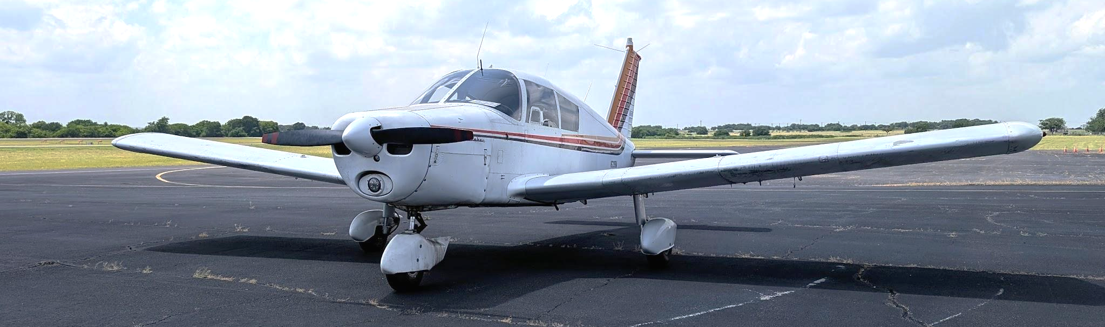
Aircraft Details:
- Total Time Since New (TTSN): 6065.6 hours
- Annual Inspection completed March 2025
- Upgrades & Features:
  - Two uAvionix AV-30-Cs installed
  - uAvionix AV-20-S installed
  - TruTrak AeroCruze Autopilot Kit 100-2 installed
  - CGR-30C Engine Monitor installed
  - Garmin Aera 760 Portable GPS installed
Engine:
- Model: Lycoming O-320-B2B
- Serial Number: L-4795-39
- Time Since Major Overhaul (SMOH): 226.6 hours
- Overhaul Date: March 1, 2017
- Compression Readings:
  - #1 - 79/80, #2 - 64/80, #3 - 78/80, #4 - 62/80
Propeller:
- Model: Sensenich 74DM6-0-60
- Serial Number: K36331
- Time Since Major Overhaul (SMOH): 276.6 hours
Additional Information:
- 91.413 Transponder Check Completed: August 10, 2022

📸 View High-Resolution Photos: Click Here
📖 Access Complete Logbooks and Aircraft Documents:
- Aircraft Logbooks
- 337 Forms
- AD Compliance Report
- AviationDB Registration History
- FAA Registry Report
- Weight and Balance
Viewings available Monday-Thursday 8am-5pm. For inquiries or to schedule a viewing, contact us today!
Email: info@planesnprops.com
Phone: (682)-420-4677

