N4047R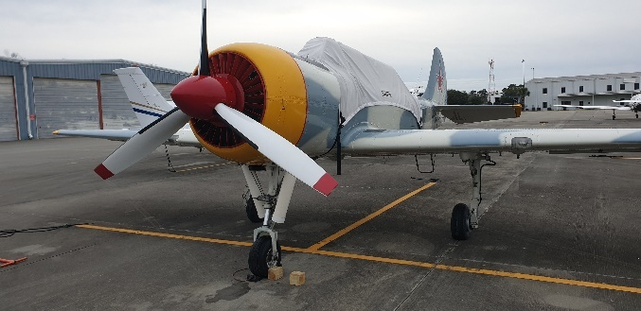
Yakovlev 52W
Serial Number 0012209
Airframe Total Time: 258 Hours
- +7/-5G Heavy Wing Spar
- Clean Original Cockpit
- Stock Instrument Panel
- Tricycle Landing Gear
- Hydraulic Brakes
- ELT
- Wing Landing Light
- Wing tip lighting
- Extended Range Wing Fuel Tanks: 2 Fuselage/2 Wing, 70 litres per side
- ICOM Radio & Transponder
- PS Engineering PM1000 Intercom
- New Tires and Tubes
- Larger Luggage Compartment
- Hooker Harness Seat Belts
- Bruce’s Custom Cover & Tool Kit
- 1 Large Scuba Tank, Hose & Fitting

Aerostar Factory Custom Configuration at time of manufacture:
- 4” legroom gain with repositioning rearward of pilot seat bulkhead and redesigned rudder pedal brackets forward for a 6’7” pilot
- 94 litre aluminum rear seat ferry tank with quick disconnect, fuselage plumbed, hard lines & fittings
- Aluminum-skinned control surfaces – no fabric

Engine:
M-14P Engine
Vedeneyev 360 HP
Engine Total Time: 258 Hours
- Intake Drain Kit
- B&C Alternator

Propeller:
MTV-9 3-Blade
Year Manufactured: 2002
Prop Total Time: 258 Hours

No Damage History

PRICED TO SELL AT $115,000 $99,500 Spring Special!

Aircraft is located in Myrtle Beach, SC and may be viewed by prior arrangement. Aircraft is under the brokerage of M-14P, Incorporated. If interested, call Jill at 928.681.4400 or e-mail: jill@m-14p.com

