1980 CESSNA 172RG CUTLASS RG II  N5393V | Retractable Gear + Constant-Speed Prop Complex-Time Platform | AV8RS  Aircraft Sales & Jet Management
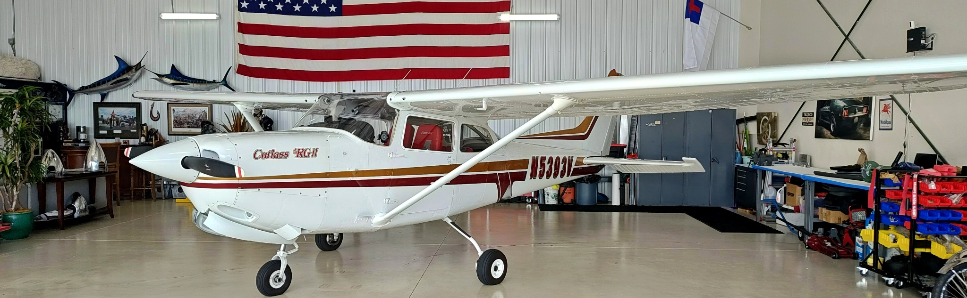
AFTT  8,755 | ENGINE SMOH  70 hrs | PROP SMOH  Verify logs | USEFUL LOAD  998.80 lb | LAST ANNUAL  06/2026 | LOCATION  Washington

Built for real “complex” time  For the pilot who wants meaningful retractable-gear discipline, constant-speed prop management, modern WAAS capability, and economical Cessna familiarity. N5393V combines a low-time engine, fresh 2022 cosmetic restoration, and a highly usable Garmin/uAvionix panel in a clean Cutlass RG II package.  WHY THIS AIRPLANE FITS THE MISSION  • Retractable-gear trainer with the familiar Cessna sight picture and handling.  • Dual WAAS navigators and AV-30 primary/HSI suite support serious IFR proficiency work.  • Fresh 2022 paint/interior gives the airplane strong ramp presence and buyer appeal.  • Near-1,000 lb useful load keeps the aircraft practical beyond simply logging time. |  | 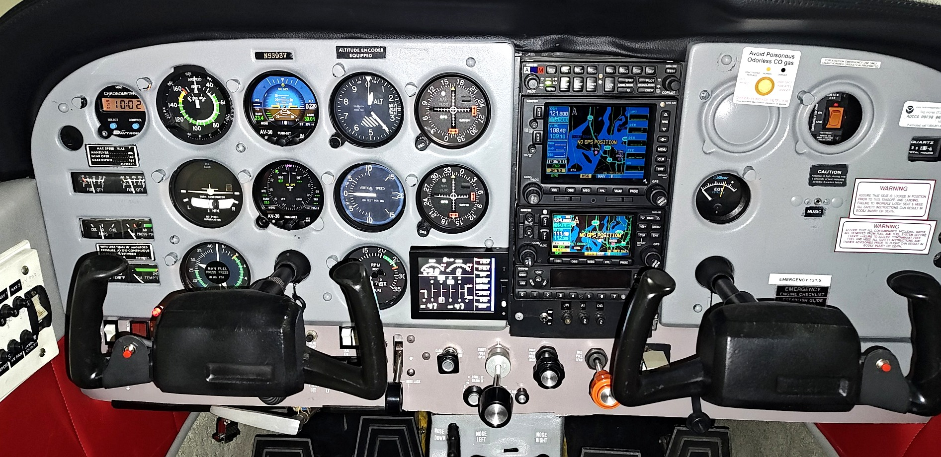  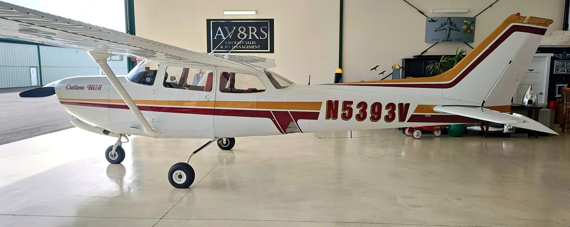
  AIRCRAFT SUMMARY
  Serial Number: 172RG0519
  Engine: 70 hrs SMOH; overhauled 03/2022; 2,000 hr TBO
  Exterior: New exterior paint and hardware - 2022
  Interior: New leather interior, lower panels, glass, door seals, soundproofing - 2022
  Maintenance: No damage history reported; complete logbooks from day one
  Hydraulics: Hydraulic powerpack overhauled 2016
  MODERN IFR / AVIONICS
  • uAvionix AV-30-C Artificial Horizon (2023)
  • uAvionix AV-30-C DG/HSI (2023)
  • Garmin GNS 530W Nav/Comm/GPS
  • Garmin GNS 430W Nav/Comm/GPS
  • Garmin GMA 340 Audio Panel
  • Garmin GTX 330ES Transponder
  • Dual Garmin GI 106A Indicators
  • Sandia SAE5-35 Encoder
  • JPI EDM-830 Engine Monitor with carb heat and fuel flow (2023)
  • ME406 ELT; vacuum system removed 01/2023
  POSITIONING
  A smart bridge aircraft for pilots stepping up from fixed-gear trainers into true complex-aircraft procedures.
Brandon Baimbridge  AV8RS LLC | 253-393-7546  Brandon@AV8RSLLC.com |  | www.AV8RSLLC.com  Aircraft Sales | Jet Management | Appraisals
Specifications supplied by seller/logbook summary. Buyer to verify all times, equipment, and airworthiness status during inspection.

