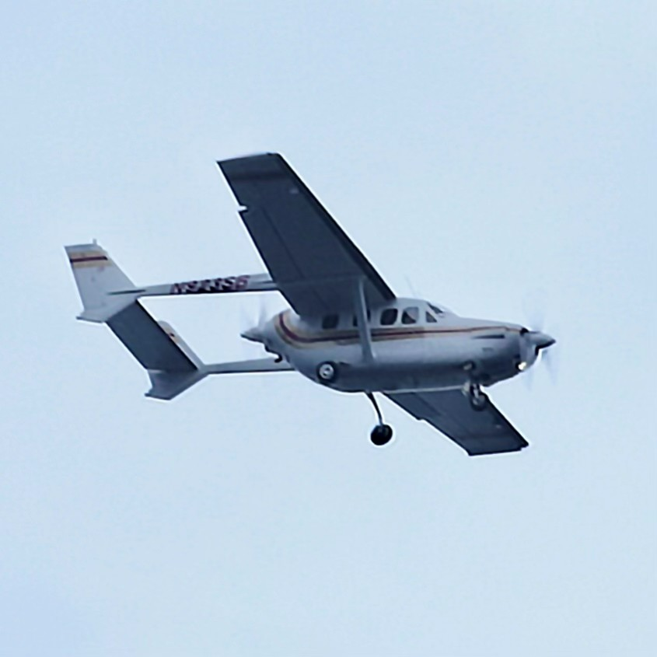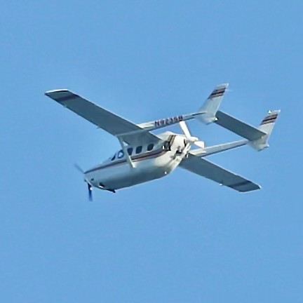✈️ AV8RS LLC EXCLUSIVE OFFERING

1/3 OWNERSHIP – CESSNA T337G SKYMASTER

N923SB | FULLY UPGRADED | TURNKEY IFR PLATFORM

________________________________________

THE OPPORTUNITY

Own a one-third share in a highly upgraded pressurized Cessna T337G Skymaster, featuring low-time factory Continental engines, modern Garmin avionics, and known-ice capability—all at a fraction of full ownership cost.

This is not a project aircraft.

This is a ready-to-fly, professionally maintained traveling machine.

________________________________________

AIRCRAFT OVERVIEW

• 1975 Cessna T337G (Pressurized Skymaster)

• Registration: N923SB

• Serial Number: P3370227

• Annual: January 2026

- AFTT 3794

________________________________________

POWERPLANT – PREMIUM CONFIGURATION

Front Engine

• Continental TSIO-360

• Factory New (2019 installation)

• Low time since new

Rear Engine

• Continental TSIO-360

• Factory Remanufactured (2017)

• ~400 hours since overhaul

________________________________________

PROPELLERS

• MT Composite Propellers

• Low time since new

• Smooth, efficient, modern performance

________________________________________

AVIONICS – FULL GARMIN PANEL

A true modern IFR platform:

• Garmin TXi 500 PFD/MFD

• Garmin GTN 750Xi + GTN 650Xi (Dual WAAS GPS)

• Garmin Remote Transponder

• Garmin Remote Audio Panel

• XM Weather & Radio

• Digital Engine Instrumentation

• S-TEC 60-2 Autopilot

o Altitude preselect

o GPSS steering

o Coupled approaches

________________________________________

De-ICE & SYSTEMS

• Full Deice System

o Boots in excellent condition (no patches)

o Heated windshield plate (operational)

• Air Conditioning

• American Intercoolers

________________________________________

UPGRADES & ENHANCEMENTS

• Electronic ignition system

• GAMI fuel injectors

• Gear Door Removal Mod (included, not installed)

________________________________________

INCLUDED WITH SALE

• Aircraft Tug ($6,200 value)

• 4x Bose Noise Cancelling Headsets

• Complete Aircraft Jack System

________________________________________

OWNERSHIP STRUCTURE

Gig Harbor Airplane LLC (Washington State)

• Sole-purpose aircraft holding entity

• Simple structure, no complex tax filings

• Operating agreement in place

Assets Included

• Aircraft (N923SB)

• Cash Reserve: $28,760.61

________________________________________

COST STRUCTURE

Purchase Price

💰 $100,000 – 1/3 Ownership

________________________________________

Monthly Dues

📊 $2,000 / Month

Includes:

• Hangar ($1,000/month)

• Insurance

• Annual inspection reserves

• Fuel for ~3 hours/month

________________________________________

Optional Cost Reduction

• Potential $1,000/month reduction if aircraft relocated to buyer-provided hangar

(Subject to partner agreement)

________________________________________

CURRENT STATUS

• Aircraft is actively flown and maintained

• Strong engine health with clean oil reports

• Only known squawk:

o TXi terrain database signature issue (software-related, fix in progress)

________________________________________

WHY THIS AIRCRAFT

This aircraft represents a rare combination of:

✔ Modern avionics

✔ Low-time twin Continental engines

✔ De-ice capability

✔ Shared ownership cost efficiency

________________________________________

CONTACT

AV8RS LLC

Aircraft Sales • Management • Consulting

Located in Gig Harbor

