Phoenix Motorglider For Sale
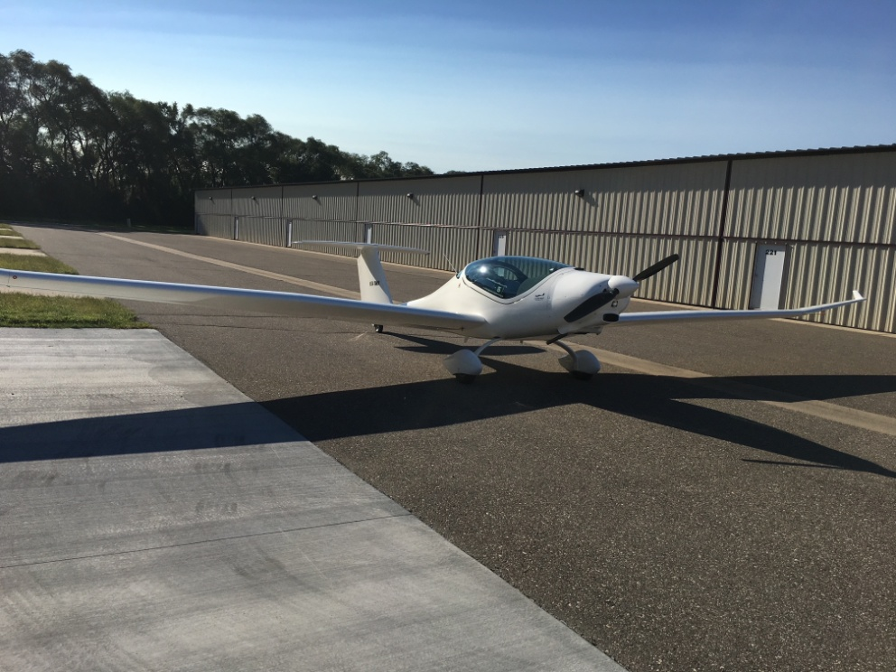
Details

Fully equipped 2 place 2015 Phoenix Air U-15 Touring Motorglider for sale

- Rotax 912ULS Engine (100hp); 425 hrs Engine; 515 hrs Total Time
- 110 knot Cruise @ 4 Gallon / hour
- 30:1 glide ratio (equivalent to K21)
- 1320 lb Gross Weight; 740 lb Empty Weight
  - 2 Adults + 100 lb baggage useful load with full fuel
- Dynon Skyview EFIS w Moving Map including ADS-B Weather
  - Mode S Transponder with ADS-B IN and OUT
  - Auto Pilot
  - Integrated COM
- Ballistic Recovery Chut
- Easily Removable 15lb Wing Tips
  - One pin & Electrical Connector
  - 35' wingspan with tips remove; Fits in standard T-Hangar
- LEMO headphone jacks; No need for headphone batteries
- Oxygen Tank
- Perfect LSA Alternative
  - No Medical Required
  - No Altitude Restrictions
  - No Night Flight Restrictions
- Excellent Aircraft for Flight over Hostile Terrain
  - At 10K' you are within final glide of an airport throughout the Carribean
  - At 14.5K' you are within final glide of an airport everywhere in the Western US.

