N235RV Specifications.
General Information: The RV-3A (150HP) offers a unique flying experience with its impressive all-around capabilities. The aircraft's excellent control balance, harmony, and visibility make it fast, agile, and fun. The single seat takes advantage of lower drag, superior visibility, and an overall “fighter-like” sporty flying experience. Only a few aircraft designs have achieved the fabulous goal of high-speed cruise and stable, slow-speed flight. This RV-3A is turnkey ready with a fresh annual condition inspection. Priced competitively at $57,000. Logbook entries from time of build completion, oil change every 50Hrs, recent Blackstone oil analysis available upon request. Really an awesome airplane. +6 -3gs. FULL AIRCRAFT COVERS INCLUDED.

Equipment Specifications:
Registration Number: N235RV

Serial Number: Year: Manufacturer: Model: Location:
Condition: Flight Rules:
Number of Seats:
10333
1998
Vans (A&P Howard Owens) RV-3A
Yuma, Arizona Used

VFR
1

Total Time Engine: Engine Model:
260 Hrs. SMOH
Lycoming O-320-A1A (150hp)

Prop:

Total Time: Prop Model:

60 Hrs. NEW PROP
Fairings ETC. Wood Cruise Prop

Modifications/Conversions/Options:
Manual Flaps Battery on Firewall Earth X Battery
Half Raven Inverted Oil
Lightweight Sky-Tec Starter

Canopy Inlet Vents
Mechanical Elevator and Aileron Trim
GRT Sport EFIS 10.5 (ADSB-IN)

Additional Items Included in Sale: Canopy Cover
Full Aircraft Covers

Avionics/Radios:

GPS:
Nav/Comm: Audio Pilot:

GRT VFR GPS

Garmin GTR-200

True-Trak

Transponder: Engine Monitor: Fuel Flow:
G-Meter
STX-165 (ADSB)
Digital: RPM, CHT/EGT, Oil Pressure/Temp

GRT GRT

Inspection Status:
Annual Condition Inspection Due: 12/2026 Transponder Test Due: 11/26
All SBs complied with and updated
Complete Logbooks from New Fuel Capacity 22 Gallons
Empty Weight lbs, Gross Weight 1150lbs

PICTURES BELOW:

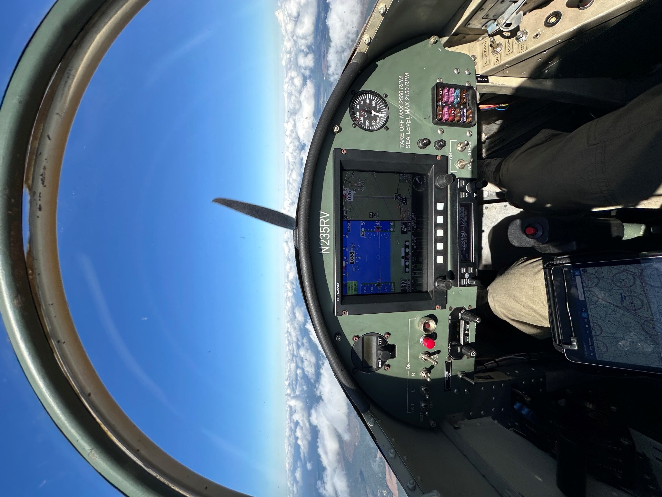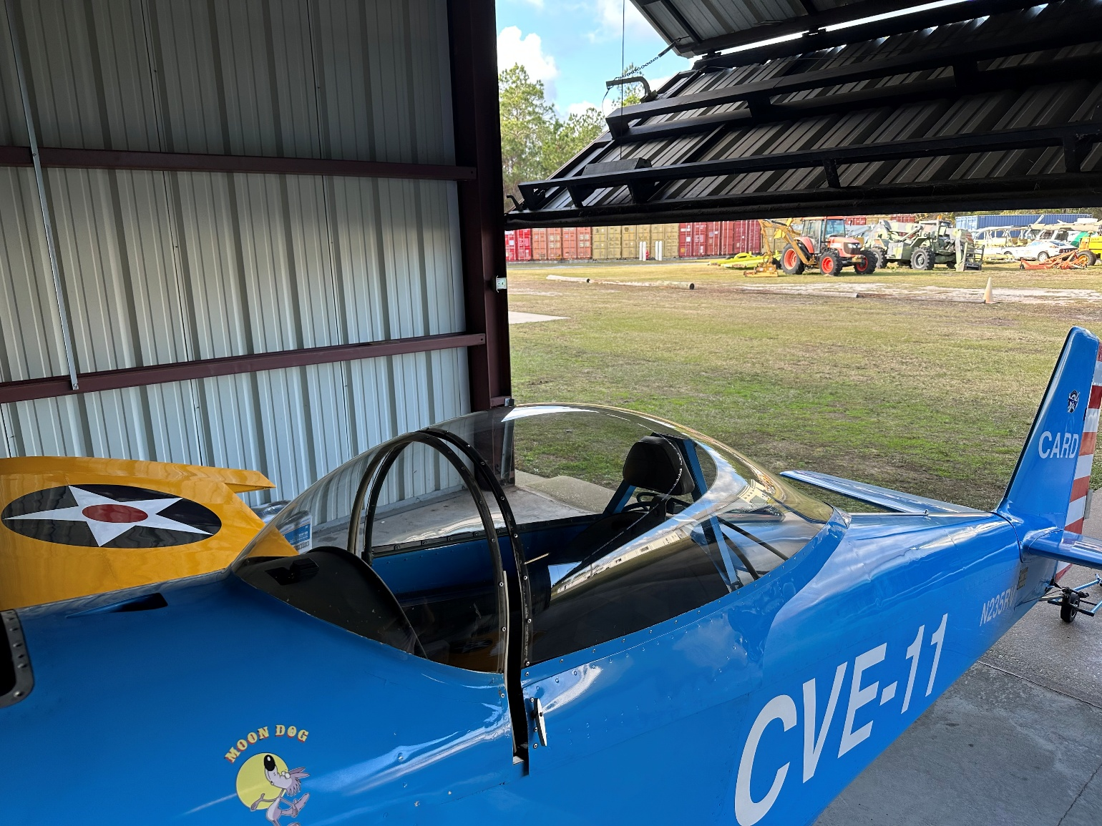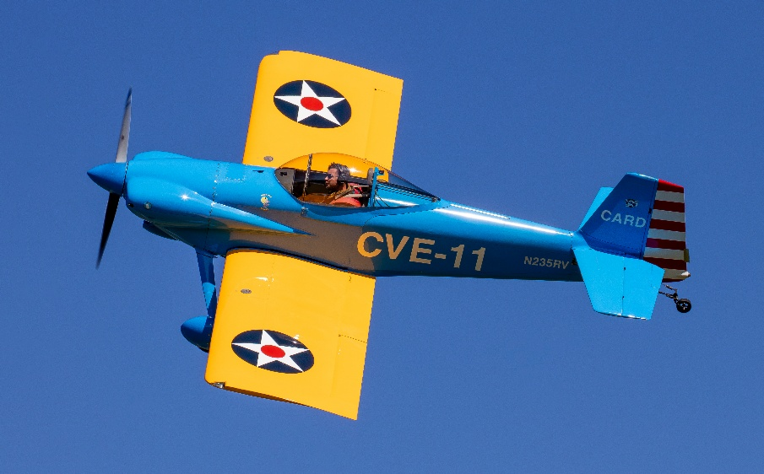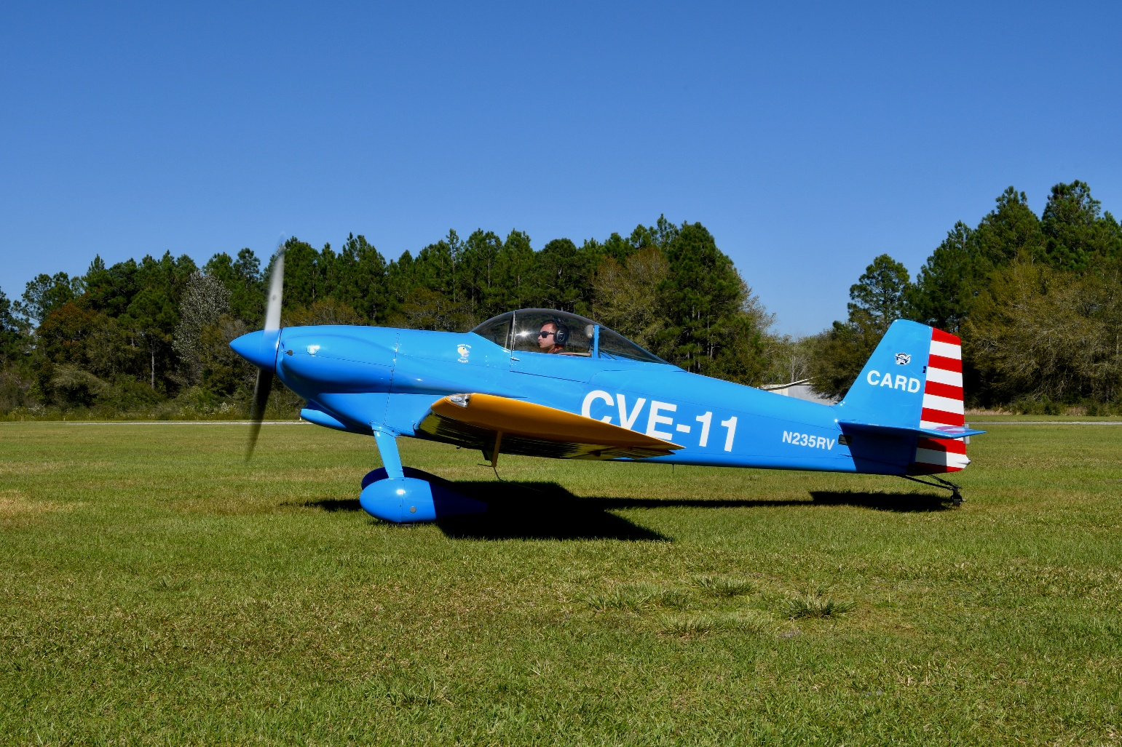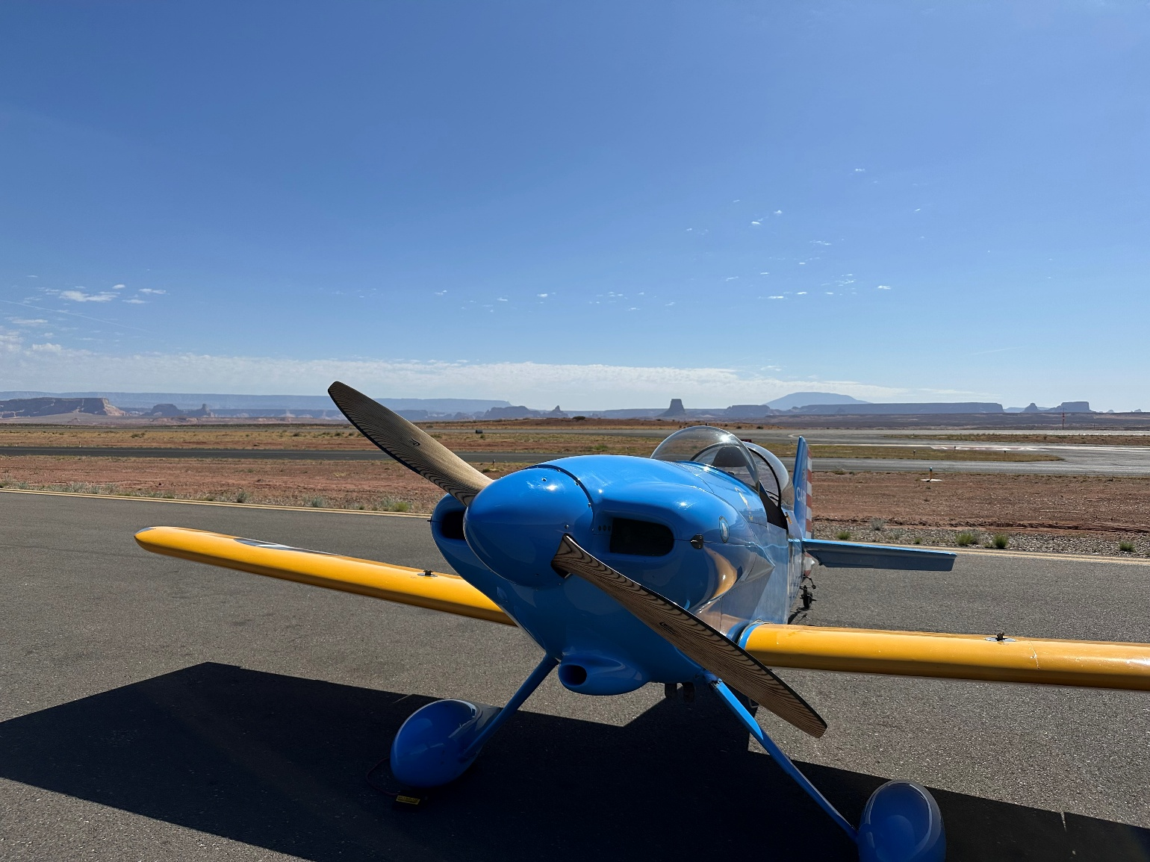

SPECIFICATIONS SUBJECT TO VERIFICATION UPON INSPECTION

