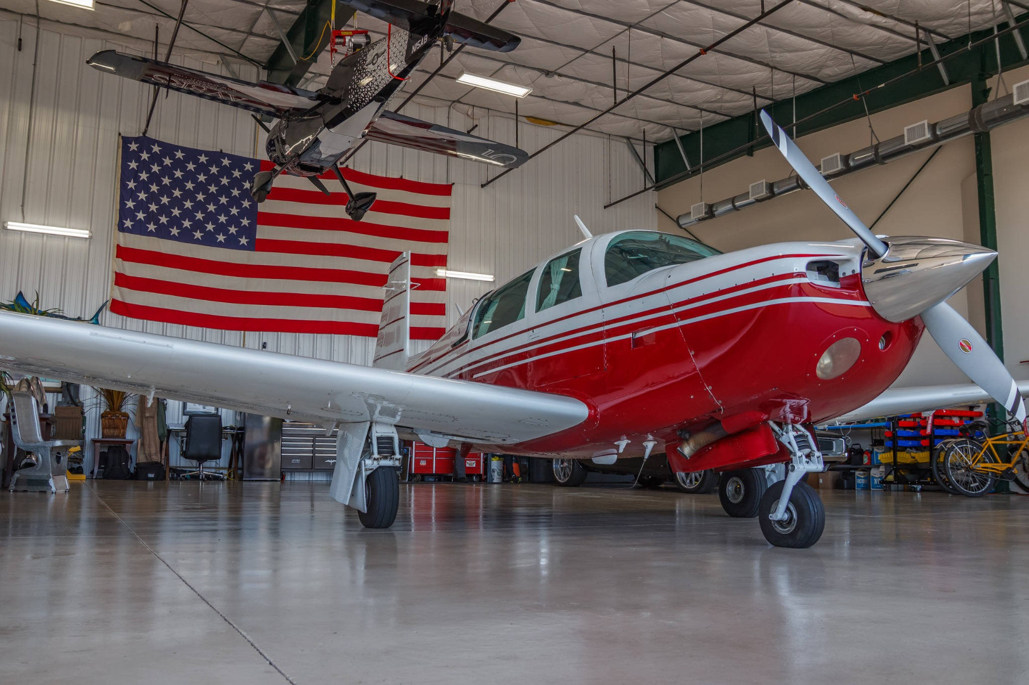  N308FW  N308FW is a 1981 Mooney M20J 201 offering efficient cross-country performance, clean Mooney styling, and a well-equipped IFR panel. Powered by a Lycoming IO-360-A3B6 with a Hartzell propeller, it features a Century 2000 2-axis autopilot, GNS-400, and GMX 2000.  CONTACT  PHONE:  253-393-7546 or 850-797-4071  WEBSITE:  www.av8rsllc.com  EMAIL:  brandon@av8rsllc.com  ADDRESS  Unit B-2, 1080 26th Ave NW  Gig Harbor, WA  98335 | 1981 MOONEY  M20J 201  N 3 0 8 F W  AIRFRAME  Serial Number: 24-1212  Model: M20J 201  TACH / TTAF: 6487.8 hrs  Engine: Lycoming IO-360-A3B6, S/N RL-30474-51E  Engine TSMOH: 481.6 hrs  Propeller: Hartzell HC-C2YR-1BFP/F7497, S/N N54532B  Prop Time: 287.6 TT  Useful Load: 1005 lbs  Complete Logs  Annual Due August 1st  AVIONICS  • Garmin GMX 200 GPS/NAV/COM  • Garmin GNS 480 GPS/NAV/COM  • Garmin GTX 345 transponder with ADS-B In/Out  • CGR-30P Primary Engine Monitor  • 2 axis-autopilot (Mitchell / Century 21)  LOGGED UPGRADES / STC ITEMS  2020 New engine mounts installed; new shock discs installed; landing gear and fuel/vacuum system maintenance documented.  2019 Garmin GTX 345 installed and configured; Hartzell HC-C2YR-1BFP/F7497 propeller installed; Sky-Tec starter installed; Mooney/Hartzell flight manual supplements noted.  2018 Factory rebuilt Lycoming IO-360-A3B6 installed; CGR-30P primary engine monitor installed; alternator, vacuum pump, baffles, hoses, and firewall-forward items documented.  EQUIPMENT / UPGRADE HIGHLIGHTS  • Hartzell HC-C2YR-1BFP/F7497 two-blade constant-speed propeller.  • Sky-Tec starter installed.  • New engine mounts installed.  • New shock discs installed; landing gear and fuel/vacuum system maintenance documented.  Logs and Photos  Aircraft photos  Aircraft logs

