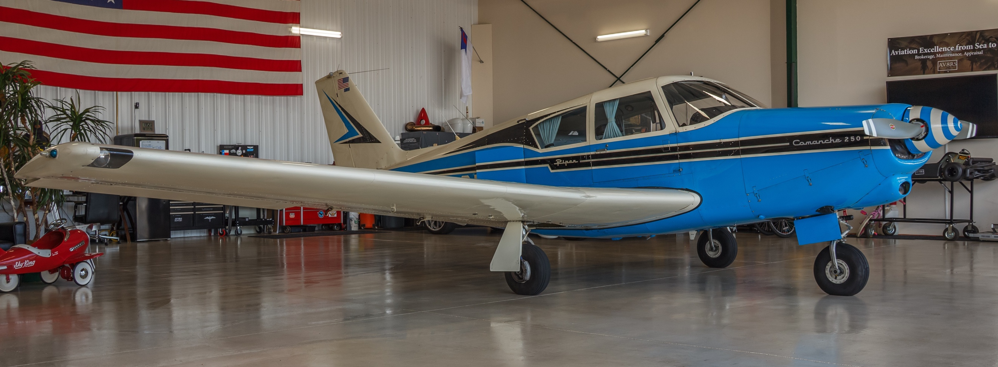 |  | 1963 Piper Comanche 250  N8266P
N8266P  Classic speed, big-bore Lycoming power, and beautiful ramp presence — a striking Piper Comanche 250.  Contact  PHONE:  253-393-7546  WEBSITE:  www.av8rsllc.com  EMAIL:  brandon@av8rsllc.com  Address  1080 26th Ave NW  Gig Harbor, WA  98335  Gallery  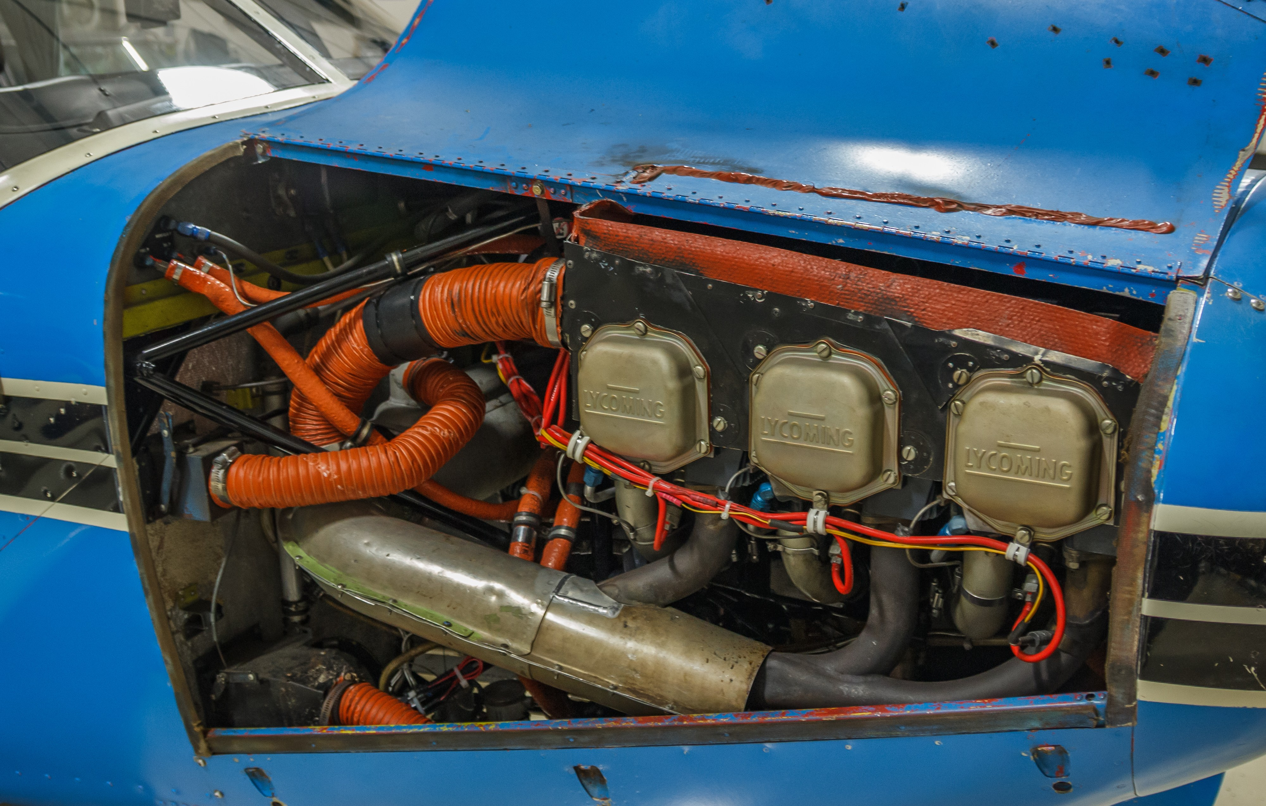  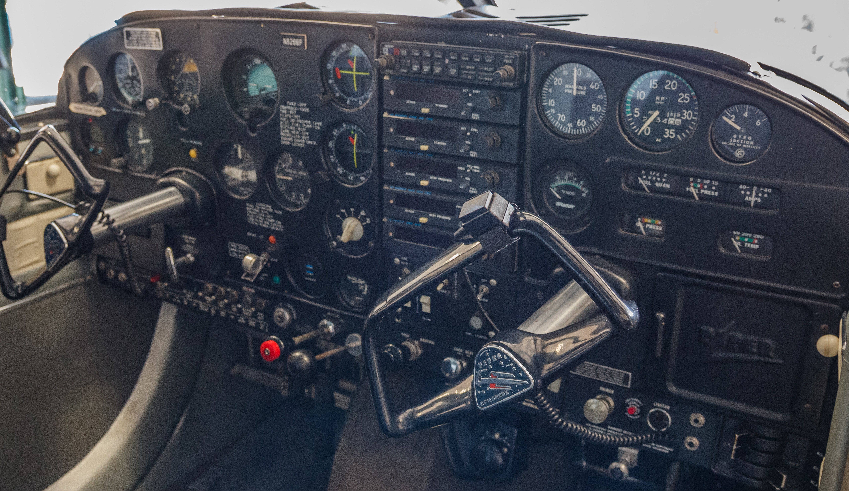  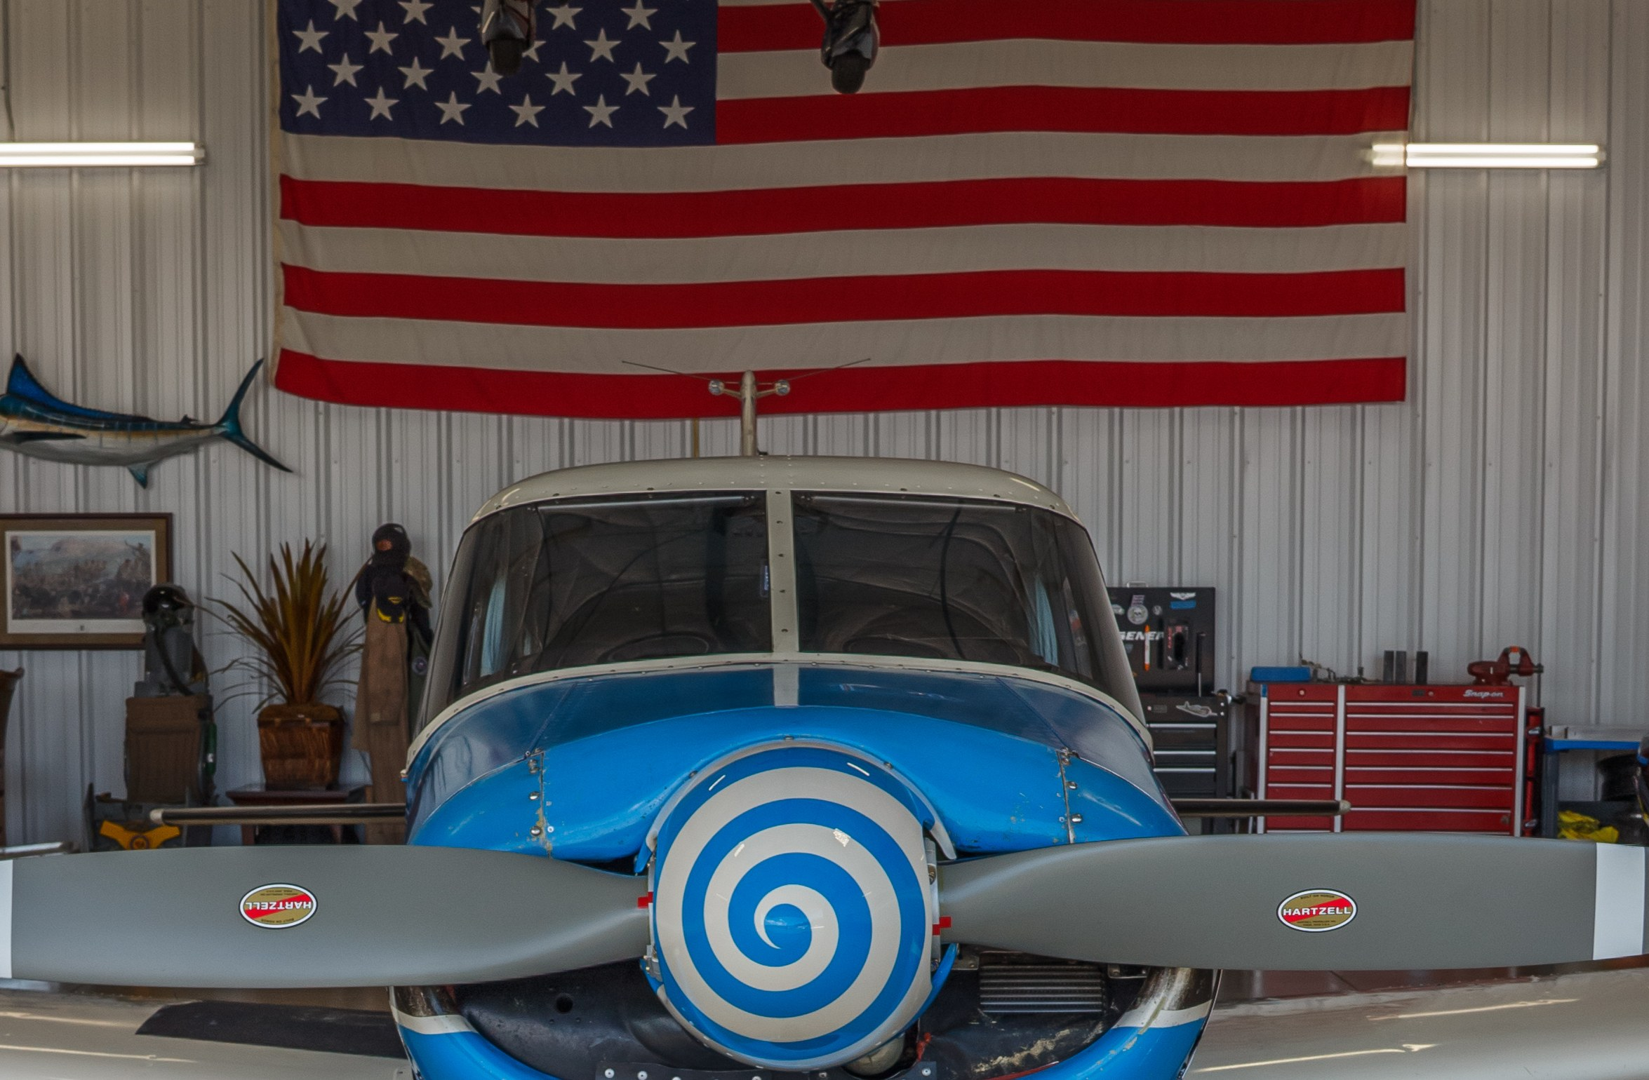 |  | Airframe  Serial Number #24-3519  AFTT - 2,232.68  No Damage History, Complete Logbooks  Engine & Propeller  Lycoming O-540-A1D5  Engine Serial #L-6037-40  SMOH ~185 hrs (Major Overhaul 05/30/2018)  Overhaul included new Titan nickel cylinders, overhauled Bendix magnetos, new Tempest plugs, new fuel pump, new oil cooler, and overhauled carburetor  Hartzell HC-A2XK-1 Propeller  Hub Serial #J304  Prop SMOH 671.61  Northwest Propeller Service rework & inspection (09/26/2023)  Annual propeller inspection completed (04/13/2026)  Recent Highlights  New windshield  New audio panel  Recent propeller repair & inspection by Northwest Propeller Service  Low-time Lycoming O-540-A1D5 since major overhaul  Attractive blue, white, and black paint scheme  Classic Comanche 250 performance and ramp appeal  Complete logbook history available for qualified buyers  Performance  Single-Engine Piston, Retractable Gear  Cruise: 157 kts  Range: 630 nm  Max Takeoff Weight: 2,800 lbs  Seats: 4  Serious inquiries only. Logbooks available for qualified buyers.  Contact Brandon Baimbridge at AV8RS LLC for details on N8266P.

