2002 Cessna T182T
$425,000.00

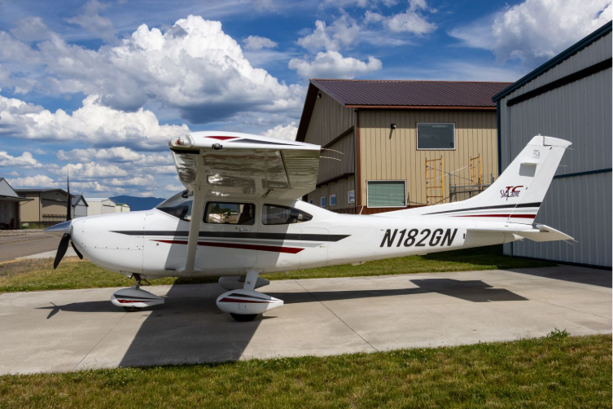

Serial #: T18208112
Tail #: N182GN
Engine: TIO540-AK1A
TTAF: 740 hours

Engine Time: 48 hours SMOH

- Ly-Con Built Engine – Premier Engine Shop Known for their quality and added Horsepower.
- NIKARAMA Cerminil Cylinders
- Cylinders were Port – Ground
- Turbo, Wastegate, Slope Controller all OH’d
- All New Hoses
- Last Annual 2/2026 all Cylinders were 78/80 or greater.
- AD 2026-04-11 Does NOT apply to this engine – The majority of T182T’s are affected by this AD that requires the Lycoming bushing P/N LW 13923 be replaced, but this engine has the superior bushing P/N SL 13923A which DOES NOT fall within the AD.
- DLC ( Diamond Like Carbon ) Coating on valve tappet bodies

Prop Time: 48 Since Overhaul

Avionics:
- Garmin G3X with Engine Instrument System (EIS)
- Garmin GTN 750
- Garmin GTX 345X ADSB IN/OUT Transponder with Subscription Free Weather
- Garmin G5 Backup Display
- PMA 8000BT Stereo Audio Panel
- KAP 140 AP with Altitude Pre-Select & trim controls.
- Bendix King Nav Radio
- ACK Tech Model E-04 406 MHz ELT
- TCW Technologies Back-Up Avionics Battery System

· Annual: Completed 2/2026, Next Due 2/2027
· FARs 91.411 & 91.413: Completed 2/2025, Next Due 2/2027
Oxygen System: Yes – Hydrostatic Check due 06/2027

Summary:
If you have been searching for an immaculate, high-performance cross-country machine, this is the one. This 2002 Cessna T182T is a rare, pristine example of the legendary Turbo Skylane. With only 740 original airframe hours and a two-owner history, this aircraft has been meticulously cared for, always hangared, and kept in a dry climate. The custom “182” N number that was chosen is a nice touch as well.
It features a flawless exterior and interior, offering a true "like-new" presence on the ramp.
Forget standard overhauls. This T182T features a zero-timed engine custom built by Ly-Con Engines - the industry gold standard for premium aircraft performance and precision balancing. You get the peace of mind, reliability, and crisp performance of a fresh, elite-tier build right from day one.
- Dry Climate Pedigree: Always hangared, preserving the airframe, paint, and windows in immaculate condition.
- Flawless Cosmetics: Easily rates a 9.5/10 inside and out. The paint shines like glass, and the interior looks and smells of factory new.
- Zero Damage History: Completely clean pedigree with meticulous, continuous logbooks.
- Turn-Key Ready: Needs absolutely nothing but a new pilot to fly it home.

