Spec Sheet: N337JL
1967 Cessna Super Skymaster

Engines:

Continental IO-360-C
Time since major overhaul: 200 hours
Both front and rear engines overhauled by Triad Aviation, Greensboro, NC

Both engine oil screens replaced with oil filter adapter to use aircraft oil filters.

Hobbs meter installed.

New aircraft battery.
Battery is equipped with battery minder.
24v battery minder is included.

Both engines have electric pre-heat installed.

New starter-generator installed rear engine.

Engines have regular interval oil change by Plane Werks, KFQD.

Aircraft:

New paint: Matterhorn White/Astro Blue - G8003 AWLGrip
New interior
Aircraft equipped with military O2 glass door for unlimited viewing from right seat.
Current annual.
Current IFR pitot-static check.
New shoulder harnesses installed.
New hydraulic power pack installed (gear retraction/extension).
New electric flap motor installed.
New sun visors installed.
Current ELT inspection.
Third row seats removed (but available)
Replaced nose gear steering cam.

Avionics
Aspen Evolution EFD-1000 PFD/ND
Garmin G-5 attitude indicator
STEC-50 autopilot w/ altitude hold.
GTX-345 transponder with ADSB.
Garmin audio panel.
JPI EDM 790 digital twin engine monitor.
Davtron elapsed time clock.
Garmin audio panel / intercom.
GTN-750 Nav/Com.
Garmin Nav/Com.

Also included:

Updated Skymaster control yokes.
Complete set of windshield and engine covers.
Tow bar.
Portable ladder.

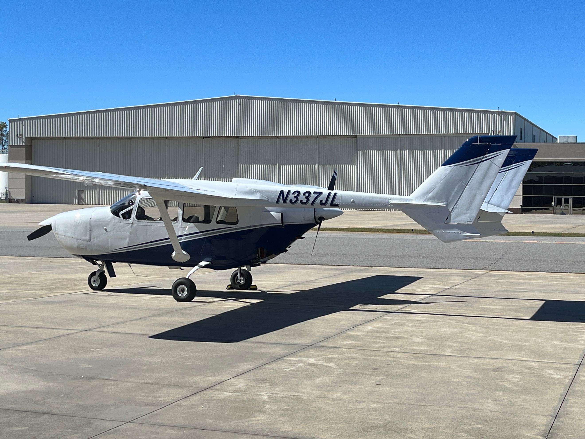

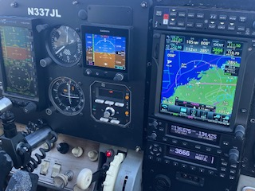

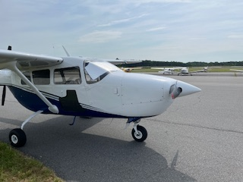

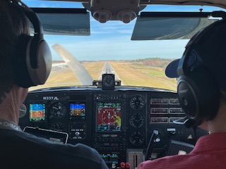

Airframe and Engine logbooks available for review.
Dozens of additional pictures available.

