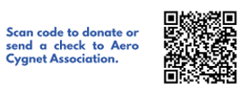
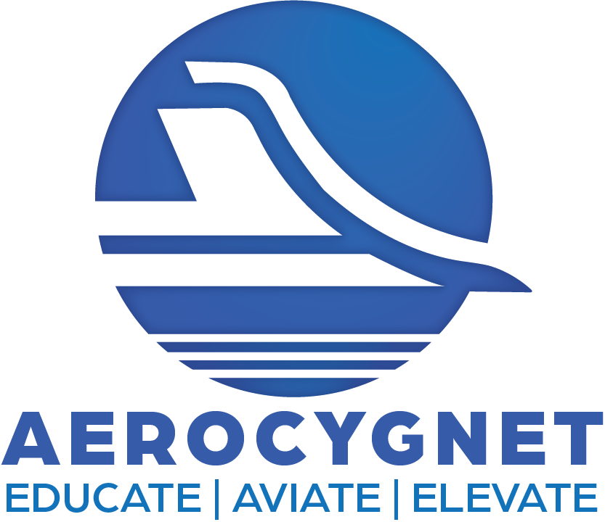
Aero Cygnet is a nonprofit organization dedicated to helping young people, (Cygnet-Young Swans) find a sense of purpose through aviation. We provide access to ground school, introductory flights and scholarships to encourage our students to consider aviation as a career option. There is a huge shortage of pilots, mechanics and airport personnel, and we aim to help fill that gap. We need sponsors and donations to help finish the airplane we are building. www.aerocygnet.org 970-286-5665 aerocygnet@gmail.com

