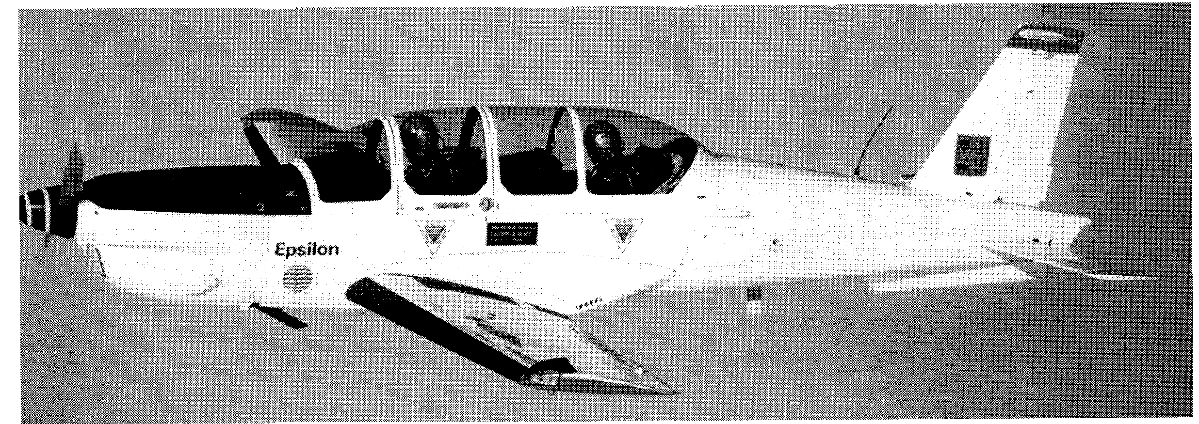
EPSILON TB30
The Epsilon is a tandem seat, retractable tri-gear, western technology production aircraft manufactured by Groupe Aerospatiale in France, w/Parts support by Daher
Max Level Speed 202 kts. Engine - 300 HP Lycoming AEI0 540L1B5D
VNE 281 kts. Propeller-Hartzell constant speed 78"
Stall speed 63 kts. Gross Weight 2,755 Ibs.
G Limits + 6.75G/-3.35G Empty Weight 1,992 Ibs.
Inverted Flight Duration 2 minutes Fuel (useable) 55.4 gallons
Wing span 26' Length 24.9' Height 8.6'
S/N 38 N638TB Mfg. 1985
Epsilon TB-30 Inc.
(805) 594-0726

