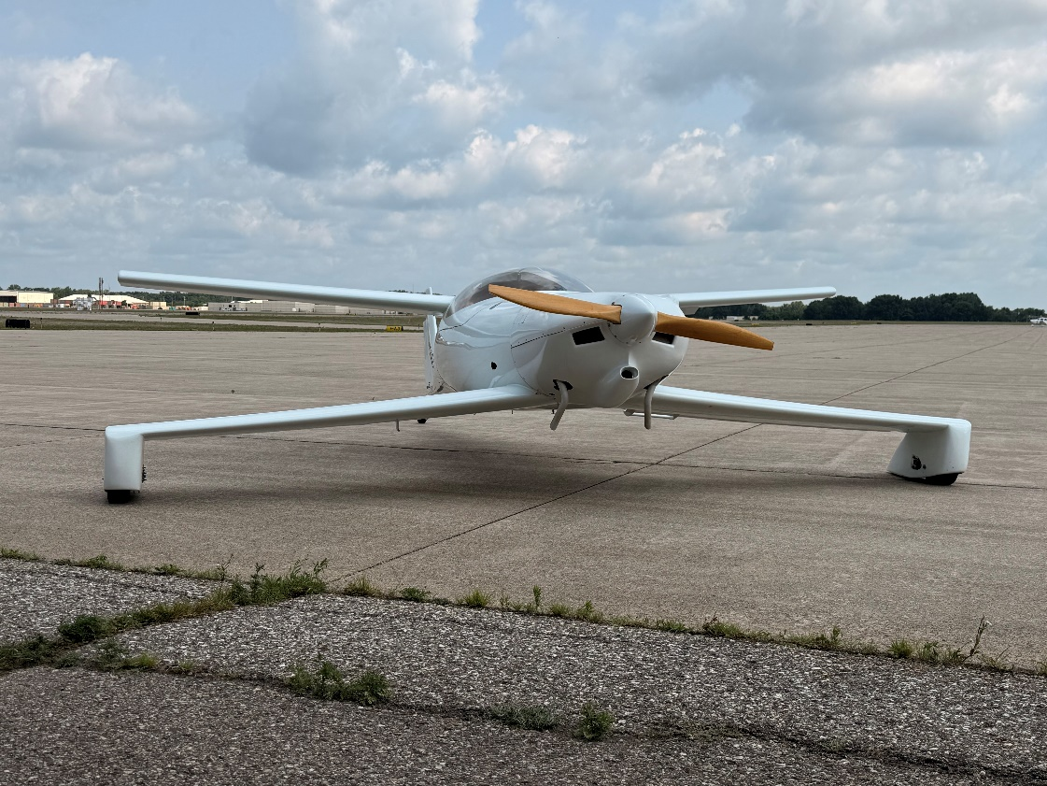
For Sale: 2012
Q-200 $34,500 OBO
FOR SALE – QUICKIE Q200 – Well Sorted LS1 Canard AIRCRAFT Beautiful, carefully built and maintained Q200 offered by the original owner and builder. Completed in 2012 and flown regularly. This aircraft incorporates many of the most desirable improvements developed for the Q200 and represents decades of refinement within the Q community.
Airframe -260 hours total time since new - Tailwheel configuration - LS1 canard (built from new, one of the most desirable modifications) -All composite flying surfaces- including; main wing, canard, vertical tail, ailerons, elevators and rudder – were professionally built by Larry Fitzgerald of Fitzgerald Composites (Bristol, Wisconsin), a highly respected composite fabricator in the experimental aircraft community. Equipped with the Jim-Bob 6-Pack handling modifications including: aileron reflexor system (acts as an additional, vernier controlled, pitch trim system allowing greater elevator authority during slow speed transition as well as all phases of flight), improved brakes, full swiveling tailwheel, bell crank separating rudder & tailwheel cables. The Jim/Bob mod’s were developed to address and refine ground handling and transition during takeoff and landing.
Engine - Continental O-200A - 1,635 hours SMOH compressions: 72/80, 74/80,74/80,74/80 Starter - Spin-on oil filter adapter - Regularly flown and maintained
Ed Sterba propeller 60”x68”, Koger Sunshade, Good paint and cosmetics, Removable Tail Cone, Light weight interior-unfinished, Complete logs and builder records - No damage history
Panel - Basic VFR steam-gauge panel, Garmin GTR200 & GPS 296, G-meter - No ADS-B Out
Weight & Balance: Maximum Gross Weight: 1300 lbs, Basic Empty Weight 662.8 lbs.
This aircraft has been owned and maintained by the builder since completion and has a fully documented history. It offers the performance and efficiency for which the Q200 is known, together with many of the modifications that experienced owners consider essential. A rare opportunity to acquire a mature, well-sorted Q200 with known provenance and exceptionally low airframe time. Located at Battle Creek, Mi.(KBTL). Serious inquiries welcome.
Reason for sale: Advancing age and reduced flying activity have led me to offer this unique Q200 for sale. I would like to see it go to someone who will continue to enjoy and fly it.
History: My father and I purchased the original kit from Quickie Aircraft Inc April 1981. The build was started then stored for several years. In 2004, I acquired a partner who supported the completion and flight test.
Contact Owner: Bruce Lombard email rbrucelombard@gmail.com
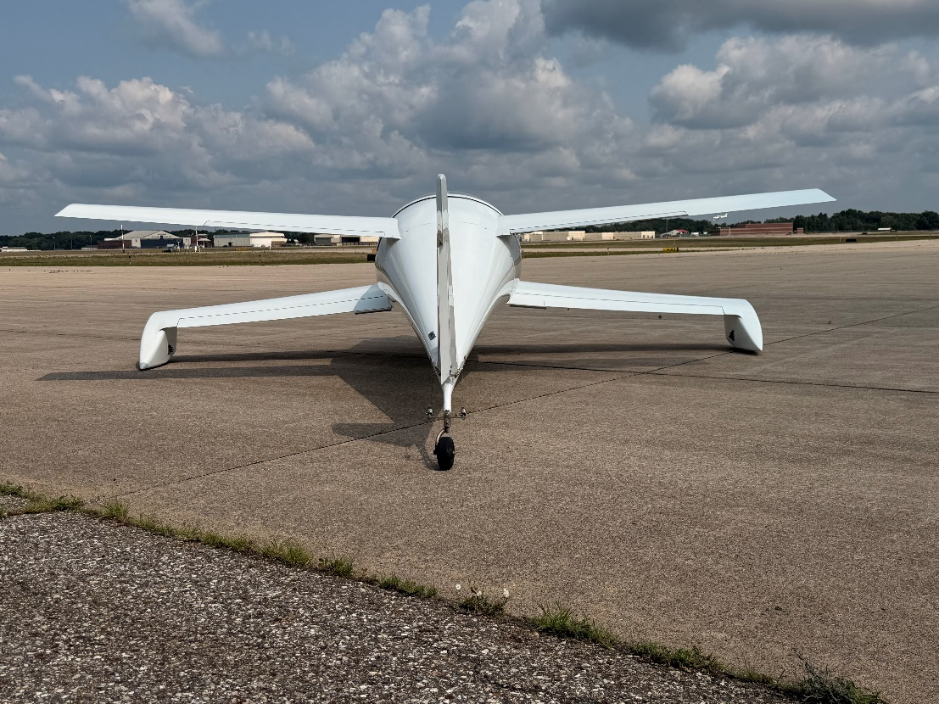

Original Q-200 Sales & Marketing Specifications:
