Skyways
FLYING SERVICE
“Blacksheep Classic Airplane Company”
P.O. Box 4327, Georgetown, CA 95634

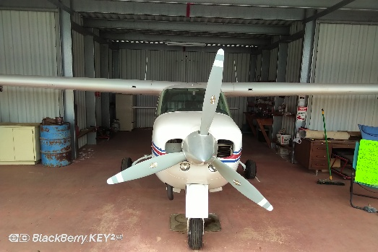
1974 Cardinal 177RG
N2121Q Serial #177RG0521
Based at E36 (Georgetown, CA) Price: $99,950.00
- Total Time Airframe: 2989.0
- Lycoming IO360-A1B6D
- Total Time Engine: 1048.0
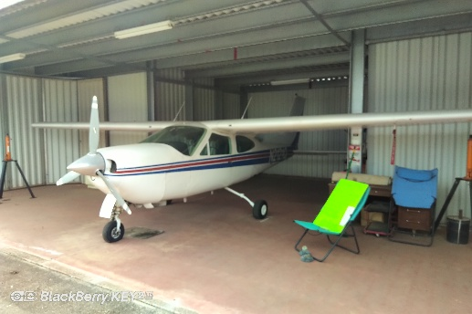
- Total Time Engine SMOH: 1048.0
- Last Annual Inspection Completed 02/24/2014. Fresh annual to be completed upon sale.
- AD 2023-02-17 complied with on 11/20/2025. Eddy Current Inspection Completed per SEL-57-09R1. Carry through
spar found to be in an airworthy condition and returned to service.
- Hartzell 3 Bladed Propeller
- Exterior:
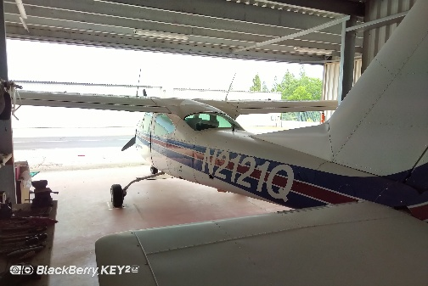
- Overall White with Blue and Red
- Condition: Good 8.0
- Interior:
- White, Blue, Gold and Red.
- Condition: Good 7.0
- Avionics:
- Narco Escort IIA Nav/Com (Navhead with G/S)
- Narco MK120 Com
- Narco ELT 10
- Narco AT150 Transponder with Encoder
- PS Engineering PM200 Intercom
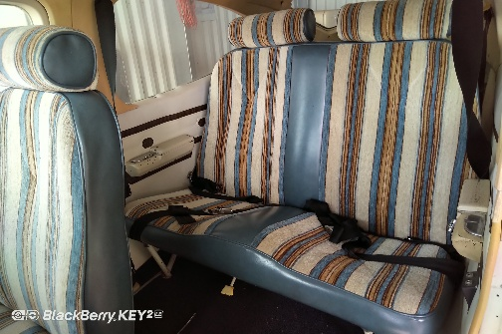
- ALCOR 4 Prob EGT
- ARNAV R-150 Loran
- Navomatic 300 Auto Pilot
- Horizon P1000 Electronic Digital Tach
- Provision Flight Alternate Vacuum System
- Astrotech LC-2 Quartz Chronometer
- ADS-B Out LED Tail Position Light, TSO
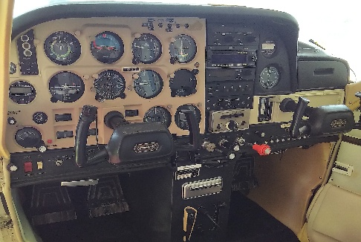
SEE TO APPRECIATE
Contact: Blacksheep Classic Airplane Co.
Steve Cimmarusti
Phone: 530-333-0810
Email: sgcimmarusti@sattraffic.com

