For Sale
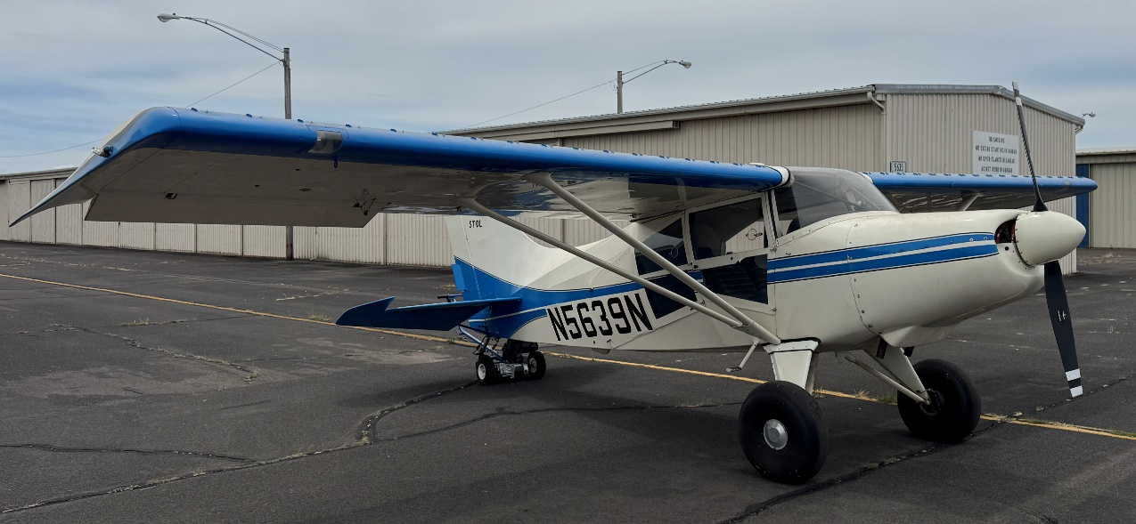
Maule M-5 210C

Location – KCVO (Corvallis, OR)
Year – 1974, Last Annual July 2026
Engine: Continental IO-360-D33A, TTE 885.7, TSMOH 257.2
- Overhaul performed by America’s Aircraft Services, 6-15-2009
- Compressions all in the ‘70’s
- Exhaust TT 789 (new in ’08)
- Mags 500 hour rebuild just completed at annual
Prop: McCauley 2A34C67-OP
- Blade MDL S-76C-2
- TSOH – 257.2 (9-16-2007)
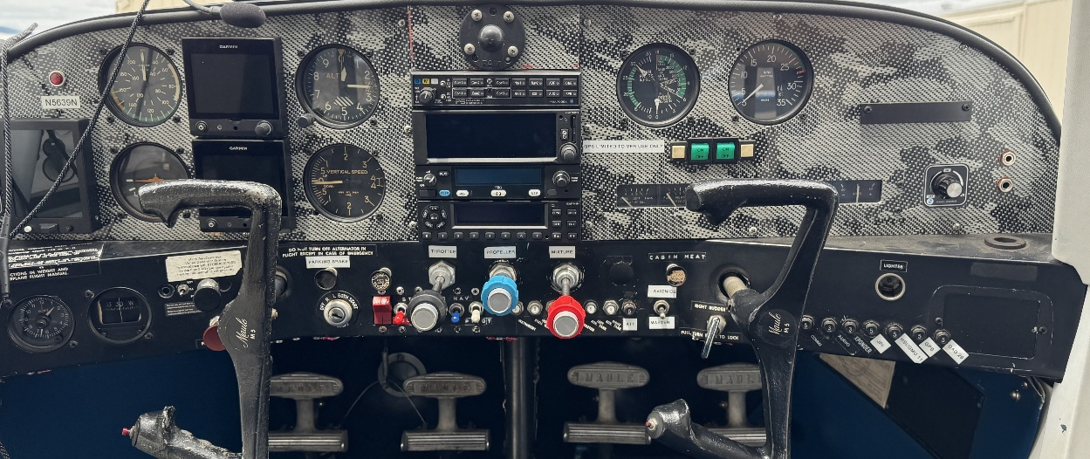
- Complete disassembly and parts replacement by Western Aircraft Propeller Service 10/20/2020
Avionics Upgraded 2020
- PS Engineering PMA 7000BT Audio Panel
- Garmin GNC 355 GPS/Com
- Radio 2 -Trig TY96A
- Garmin GTX 335 Transponder with ADS-B Out
- Garmin G5 ADI
- Garmin G5 HIS
- JPI 830 Engine Monitor with Fuel Flow
- GAD 29B
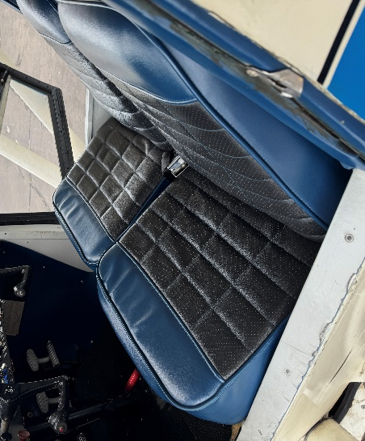
- GMU 11
Interior 8/10; Exterior 7/10
Other
- Micro VGs
- Large Cargo Door
- Cleveland Wheels with Double Puck Brakes
- Rosen Visors
- 26” Goodyear tires
- Gross Weight 2300, Empty Weight 1558, Useful load 742
- Auto Fuel STC
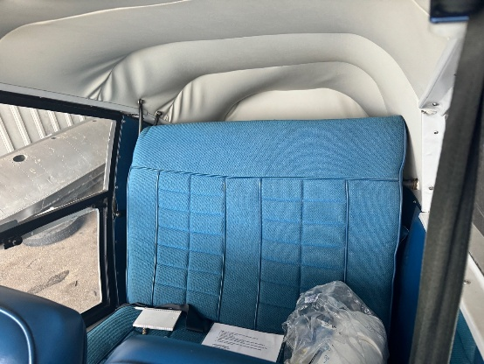
- Headliner in great shape
Great STOL performance aircraft. The 6-cylinder IO 360 is super smooth and reliable putting out 210 hp. 20-degree, and 40 degree flaps, 26” Goodyear tires, Cleveland Wheels and Brakes, Scott 3200 tailwheel, new avionics including dual G5s, Garmin GNC 355 Nav/Com, JPI 730/830 engine monitor.

Here’s a great video describing the Maule M5-210C ; Bing Videos

