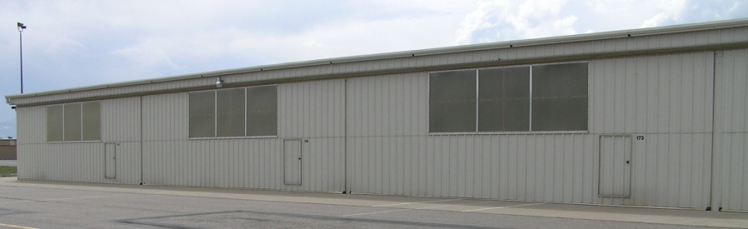
T-Hangar Space for Rent
At Rocky Mountain Metropolitan Airport (BJC)

- Available October 1, 2026
- Building 2200, Unit #166
- West Facing, approximately 1000 square feet in area
- Electric bi-fold door with Lexan panels for natural light
- Full interior walls
- Concrete floor and perimeter ramp
- Full 50-amp electrical service including metal halide interior lighting, 240-volt outlet for compressor or other equipment and 3 sets of double duplex 120-volt outlets.
- Gutters to prevent ice buildup in front of doors
- $750 per month

Call Keith Griffith at 303-887-7120
Keith.griffith@comcast.net
The Hangar Gang, LLC
