AV8RS LLC | AIRCRAFT SALES & BROKERAGE
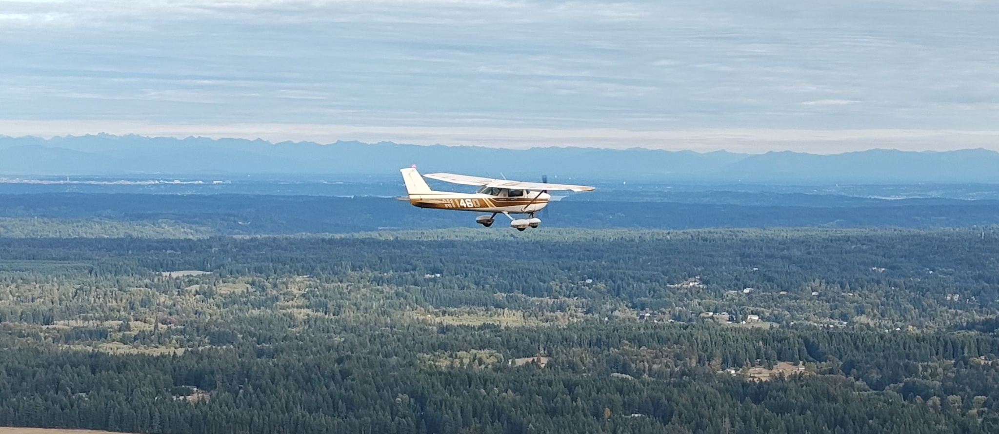
1973 CESSNA 150L
N11460 • S/N 15075439
AFTT  2,939.5 Hrs | ENGINE SMOH  1,261.1 Hrs |  | ANNUAL  Aug. 20, 2026 | LOCATION  Washington

ENGINE  • Continental O-200-A, 100 HP; S/N 251339-A-48  • 1,261.1 SMOH  • Major overhaul documented 10/09/1976 at 1,678.4 TT  • Latest compressions: 74/80, 76/80, 66/80, 72/80  • Borescope completed at 2026 annual; no foreign material noted in oil filter  PROPELLER  • McCauley 1A101/PCM6948, S/N G12624  • Fixed-pitch aluminum propeller  RECENT MAINTENANCE  • Fresh annual completed August 20, 2026  • Aircraft weighed; weight & balance updated  • New Gill G-25 battery; new induction and vacuum relief filters  • Primer system cleaned; LH fuel drain replaced  • Wheel bearings serviced; ELT battery replaced (due May 2031) | NOTABLE PRIOR MAINTENANCE  • 500-hour magneto service; starter overhauled; spark plugs replaced  • Engine isolation mounts replaced  • Nose gear strut honed/resealed; shimmy damper shaft replaced  • Brake wheel cylinders honed/resealed; brake lines replaced  • Prop spinner bulkhead replaced; flight-control cable rigging corrected  AD / RECORD STATUS  • Ignition-switch, vertical-fin nutplate, and seat-rail inspections documented current at latest annual  • Full logs  • No NTSB accident record located  EXTERIOR  • Classic white with brown/gold trim  • Wheel pants installed  • Traditional 1970s Cessna appearance
LOW-TIME CESSNA 150L | DOCUMENTED ENGINE HISTORY | FRESH 2026 ANNUAL
Specifications subject to verification from aircraft records and physical inspection. Buyer should confirm all times, equipment, inspections, and records during pre-purchase review.

