1966 Mooney M20E Super 21 for Sale
$80,000 OBO, Long Range, IFR-RNAV VOR ILS DME, Autopilot
ACTT: 7805 hours
Hartzel Prop TSPOH: 1093.9 / Total Time: 1093.9
Engine TSMOH: 2472.5 (There’s a Story here, I’m probably not crazy, please keep reading)
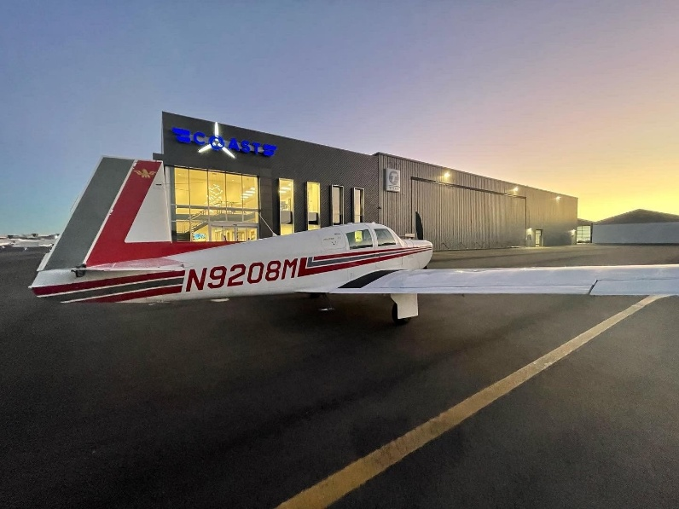
Engine Time Since New: 5276.8
Compressions: 78/76/74/76 (2026 Annual – October 2026)
Always Hangered, at least since 1984: KSNS KRBL and currently KCVH.
IFR Certified and frequently flown IFR
STEC-30 2-axis autopilot (nice for SPIFR operations)
Garmin 430WAAS LPV, ILS, Dual VOR, DME IAP capable

Inspections/TBO/MX:
Transponder and Pitot static inspection completed 5/19/2026
Next Annual due November 2027
Weight and balance updated 2025
ELT Battery due 3/31/2029
ELT switch battery 3/31/2029
Main Tanks were Resealed by Weep No More in Wilmar, MN (2022)
Engine Oil analysis through Blackstone labs since 2020

IFR Redundant Instruments:
Dynon stand-alone Standby EFIS
Precise Flight Standby Vacuum System/alternate static Installed.

Upgrades:
Lycoming IO-360-A3B6
Upgrade over original Lycoming A1-A, better cam shaft = no RPM avoid range, more reliable dual ignition system, better lean of peak operation)
Long range Monroy Aux Tanks
86 Gallons total usable fuel; airplane has been flown coast-to-coast nonstop by previous owner.
Whelen LED Landing light
Flight Enhancements Auto-Step Mooney Electric Retractable step actuator retrofit kit Installed (2021)

Avionics:
Garmin430 WAAS
J.P. Instruments FS-450 Fuel Flow Meter
S-TEC 30 two-axis Autopilot (Couples to Garmin 430 or VOR/Localizer)
KI-55A HIS
King KN-64 DME
King KMA-20 Audio Panel
Dynon Avionics D2 Pocket Panel Portable EFIS (Stand Alone)
King 155 TSO Radio with glide slope, King KI-203 Indicator
Garmin GTS 335 ADSB IN/OUT Transponder w/ encoder
Garmin 695 yoke mounted Interfaces with Garmin430 as well as XM weather antennas
NAT 4-place Stereo Intercom
201 Style Instrument Panel

Engine Upgrades:
Tempest Fine wire spark plugs (x4 bottom ones)
Surefly Electronic magneto (Impulse) only has 250 hours on it with a 2400 TBO.
New Ball stud Muffler Exhaust fabricated by Plane Xhaust Corp and modified to have slip joints (installed 2025)
All new Precision Hose Technology Inc. Firewall Forward Engine hose kit with Fire Sleeves (2025)
Aero Accessories Fuel pump installed (2024)
Conventional Slick Magneto has 250 hours on it (500 hour TBO)
New ACS Products Ignition switch (2025)
New ignition Wires

Damage History:
In 2013 the previous owner had a near gear up landing prop strike. After the propeller hit the ground he went around, extended his gear, and then landed. Afterwards he seems to have handled the mx properly. New prop, hub and had the Engine sent to Eagle Engines for an IRAN inspection. This was about 1100 hours ago. So there was a significant partial rebuild of the engine 1000 hours ago. New Piston Rings, crankshaft, deglazed cylinders, Replaced the exhaust guides, ground and lapped valves and seats, and the engine was completely torn apart clean and inspected and put back together IAW Lycoming Overhaul instructions. Of course he had the prop governor overhauled and put on a new prop. I can’t advertise the plane as a 1500 TSMOH engine but so far all my compressions, oil analysis, and oil filter cuts seem to support that the engine is behaving as a 1500 hour engine. Why overhaul an engine that’s running great? Honestly, I’ve known more pilots have a near 0 TSMOH engine quit on them than anyone carefully going beyond TBO. I’m negotiable on price but I think the next owner has a opportunity to get a great plane at a lower price point and continue to run it beyond TBO.

Why am I selling:
Honestly, it’s tough for me to put this plane up for sale. It’s been my time warp machine for the past 7 years and enabled my long-distance relationship to seem not so far away and enable more visits to my family. Great plane to get to Utah for the annual elk hunt as well. I came to the conclusion to sell when my 2nd daughter was born. This plane was great for me and my wife with our dog, but mooney’s are a bit tight on cabin space when you have 4 people. Also, I seem to be flying it less and less with the arrival and workload of 2 kids under 2. I usually just use it to commute for work for extra shifts at different EMS bases or for a solo trip somewhere. It’s starting to feel a bit selfish. I would like to sell my plane to begin saving up for a larger one. Maybe a twin?

Paint 6/10
Interior 5/10

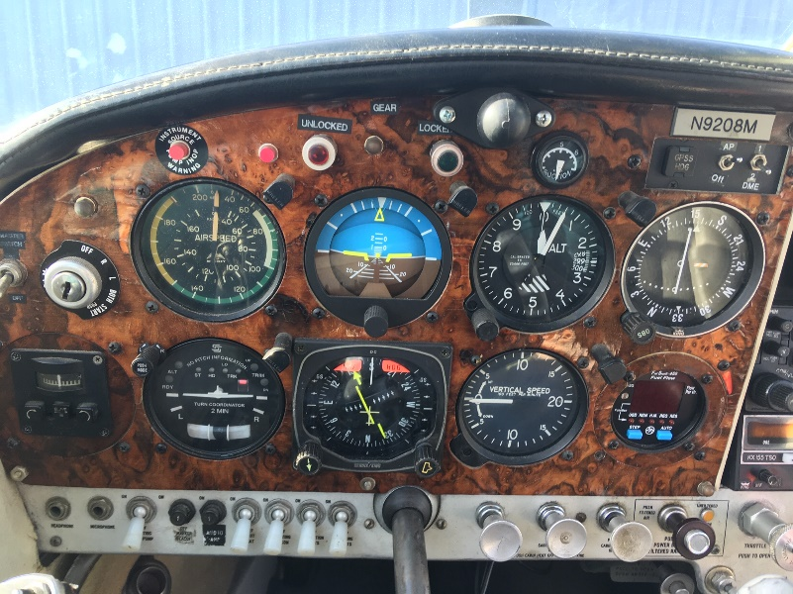 | This is the left side of the 201 style panel. It contains the basic 6 flight instruments including the King HSI. The STEC Autopilot is embedded in the turn coordinator. The JPI Fuel Totalizer is in the lower right under the NAV #2 indicator, The autopilot mode switch (GPS or Heading) is on the upper right. The altitude hold and autopilot disconnect switches are on the yoke.
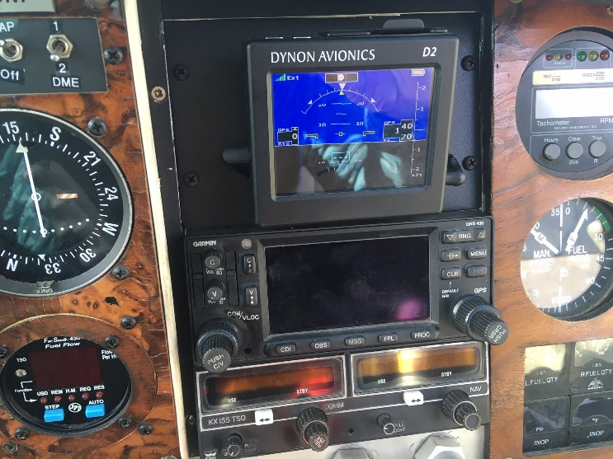 | This is the center radio stack with the Garmin 430 in the middle with the Number 2 NAV/COM King KX-155 below. Above the two radios is the backup Artificial Horizon, a Dynon D2 which acts as a mini glass panel showing attitude, altitude, and rate of climb. It derives its altitude information from GPS satellites. Since the yoke mounted 695 gives me a big picture for navigational awareness, I normally display the TIS traffic page on the 430 when enroute.
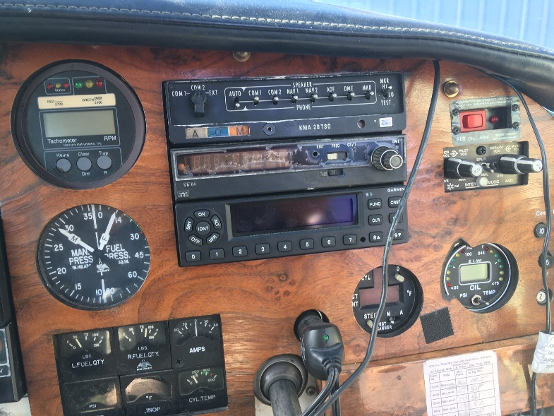 | This is the right side of the instrument panel. In the center is the King KMA-20 audio panel, the King KN-64 DME, and the Garmin GTS-335 ADSB transponder. The transponder also transmits traffic and weather via blue tooth suitable for display on a tablet computer running ForeFlight software. Also in the picture is the, the JPI 8-point temperature gauge, the NAT 4-place intercom, and the digital oil temperature/pressure gauge.
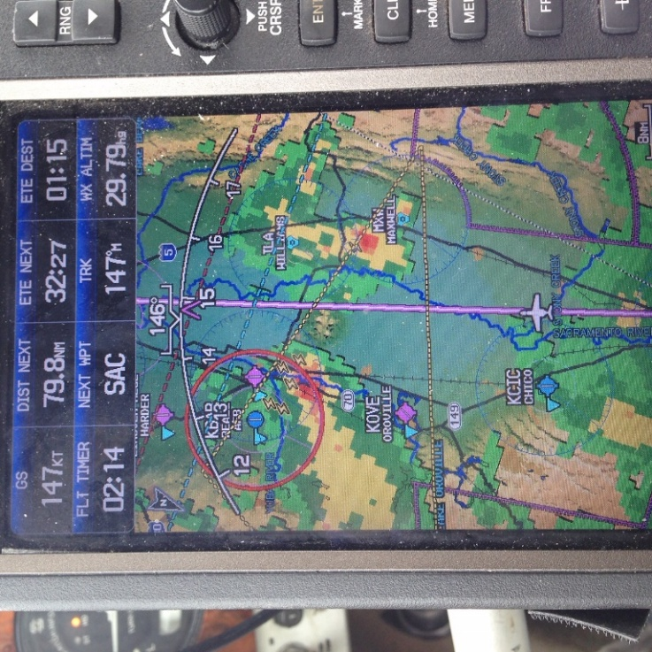 | This is a photo of the Garmin 695 Mounted on the pilot-side yoke. It is powered by the aircraft with battery backup. It has its own GPS (providing backup) and Nav data database including all instrument approach charts, airport diagrams, SIDs and STARs.  It displays whatever flight plan has been entered into the Garmin 430.  But most significantly, it displays Sirius XM weather which has significantly better resolution over the ADSB weather broadcasts available on the Garmin 430. In this picture, I am threading the needle between two thunderstorms over the Central Valley in California

